Trapdoor Technical Rider
Thanks very much for showing an interest in booking Trapdoor!
Below is a list of requirements that would make the perfect show. Of course, we understand that each venue has a different set up and we are completely happy to work within these constraints. Please just get in touch a few days before the gig if any major changes need to be made.

Stage Set Up
- 1 Drum Kit
- 1 Bass Guitar
- 2 Electric Guitars
- 1 Keyboard
- 5 Vocals
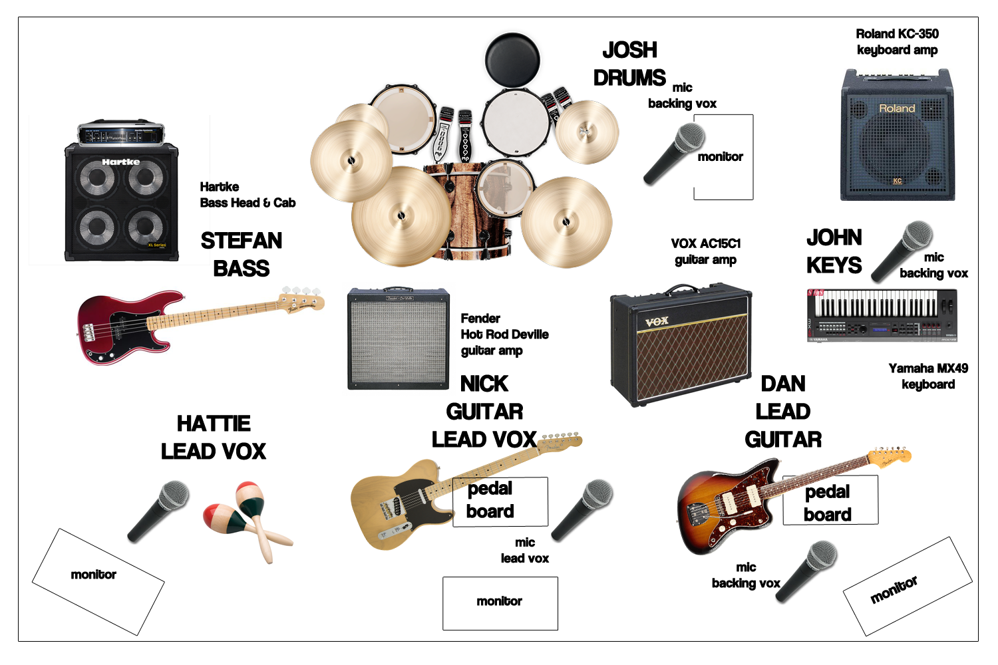
Stage Plan

Trapdoor can provide:
Instruments:
- Epiphone Dot.
- Fender Jazzmaster.
- Fender Telecaster.
- Gretsch G6128T-1962 Duo Jet.
- Fender Aerodyne Jazz Bass.
- Yamaha MX49 Keyboard.
Amplifiers:
- Vox AC15C1 (Guitar).
- Fender Hot Rod Deville 212 (Guitar)
- Hartke Head & Cabinet (Bass).
- Roland KC-350 (Keyboard).
Drums
- Gretsch Catalina Club full kit w/ kick, snare, hi-hat, rack tom, floor tom, cowbell, crash and ride cymbals.
Microphones
- 2 x Shure SM58.
- 1 x Shure SM7B.
Miscellaneous
- 5 x guitar stands.
- Percussion (shakers, tambourines, bongos etc).
- Sufficient guitar cables.
- 2 x microphone stands.

The venue should provide:
- Sound engineer
- P.A. system - for at least 4 vocals, plus bass and keyboard if the sound engineer prefers.
- Monitors – as many as possible.
- Vocal microphones – for at least 4 vocals plus mic stands.
- Drum microphones – if possible.
- Sufficient XLR cables for 4 vocal mics and up to 2 DI’s.
In order to achieve the best results for the concert, we urge sound engineers to listen to our music beforehand, in order to know the sound we want to replicate.
You can listen to our music for free at:
http://www.soundcloud.com/trapdoorband
Many thanks.
Trapdoor

Contact

Trapdoor are:
Nick Fox, Dan Linke, John Robinson,
Stefan Preoteasa, Hattie Blake and Joshua W. Bright.
Email: trapdoorofficial@gmail.com
Facebook: www.facebook.com/trapdoorband
Twitter : www.twitter.com/_trapdoor
Instagram: www.instagram.com/_trapdoor
Tel: +49 1575 0362 999 (Dan Linke)

