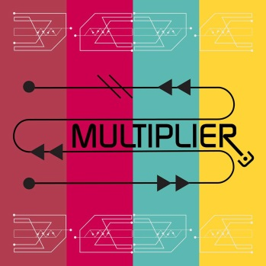

Multiplier

“A cut above”- Bagging Area Blog
“Strong songwriting combined with consummate musicianship”- Ralph’s Life Blog
“A promising debut”- Even The Stars Blog
“Rather brilliant indeed!”- Salford City Radio
“Brilliant. We love these”- BBC Introducing, Manchester

Manchester based Multiplier unveil the follow up to May’s well received debut EP on Monday 26th October 2015. A ‘Double A’ side single, Wait by The Gate/ Chasing Shadows will once again be available on a ‘pay what you want’ basis via Bandcamp and a very limited edition CD. Intelligent pop music in the very broad area also covered by early Radiohead, Elbow, and Doves

Chasing Shadows is the very first song Andy and Phil wrote together back in 2011 and has been a live favourite ever since. Wait by the Gate is the first song written in the rehearsal room by the whole band.

Multiplier made their debut at the tail end of 2012, opening for the highly acclaimed ILiKETRAiNS at The Deaf Institute, Manchester. Further shows sharing the stage with bands as diverse as Six by Seven, The Woodentops, Ultrasound and Blossoms as well as a series of smaller venue gigs have seen the band develop and enhance their powerful and dynamic live sound.

Radio plays of their debut EP by BBC Radio 6, Salford City Radio and Radio KC amongst others together with a live interview and session with BBC Introducing Manchester have seen the band significantly increase their profile and presence since May of this year.

The band has enjoyed a bit of a break due to weddings and babies (!), but will be back playing live in November.

Multiplier are:

Andy Gardner- Vocals
Phil Hartley- Guitars
Danny Callaghan- Bass
Rod McFarlane- Drums

Contact:
Phil Hartley: 07970 742484 (please do not publish!)
multipliertheband@hotmail.co.uk
facebook.com/multiplierband
twitter.com/multiplierband
multiplier.bandcamp.com

