Eles Estão de Volta !

bELA e Fernando Ferreira da banda Ménage regressam a Portugal na próxima semana para mais imprensa, TV e rádio com entrevistas e showcases a promover o seu novo álbum "The Great American Lie" tal como as próximas tours.

Não percem os seus concerts ao vivo: FNAC Almada - 26 Novembro pelas 22h00 & Texas Bar Leiria - 28 Novembro

(bELA/ Fernando Foto: Carlos Teixeira Photography)

www.menagetheband.com

They're Back!!

Fernando & bELA Ferreira from Ménage are back in Portugal next week for more press, TV appearances, radio interviews & showcases promoting their new album "The Great American Lie" as well as upcoming Tours. Don't miss them showcasing live at Fnac Almada Nov 26 22pm & Texas Bar - Leiria Nov 28th
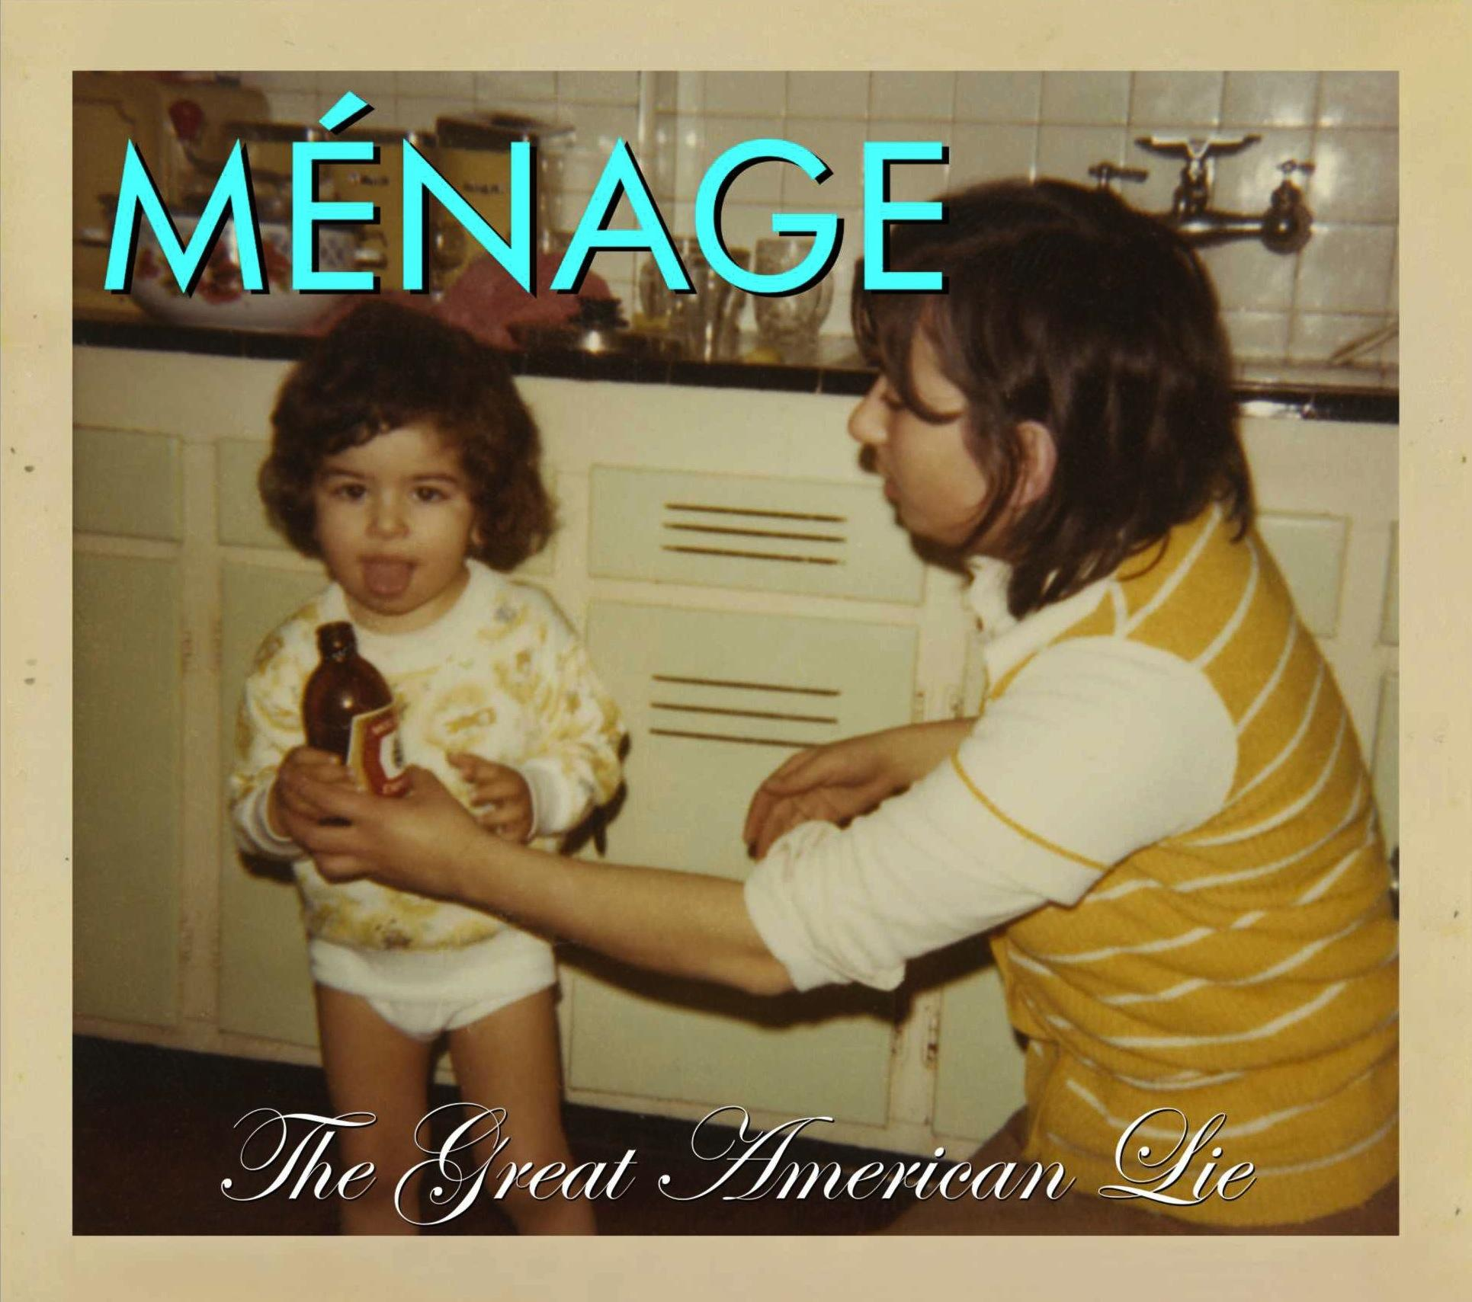

Ménage - "The Great American Lie"
Disponível Agora !!

Track List
Our Time is Now
A Beautiful Disaster
High all Night
Where were you
To The End
The Great American Lie
Love Song
Promises
Stay
Black + White TV

Lyrics & Music: BF Ferreira, B Ferreira, G.Ferreira
Produced by: David Bottrill, Dale Pinner & Dan Weston
Mastered by: Joao Carvalho Mastering
CD Design: Mafalda Silva

www.menagetheband.com

para mais info:
theportugalmusicscene@gmail.com
(+351) 918595002

