TECHNCAL SPECIFICATIONS

Name of Band: Jabba Cartel

Band Leader: Tom Voce
Tel: 0778 666 8846

Names of band members:

Adam Jurewicz
Tom Voce
Carol Whitworth
Leo Steeds

Instruments played:

Acoustic Guitar, Amp – (DI required + additional amp mic if required)
2x keys – (2x DI required)
Bass – (amp and DI required)
Drum kit + Congas to replace tom toms (tom mics, snare, kick and 2x overhead mics required)
2x Vox (2x SM58 req)

Amps:
Hartke Kickback (120W)
Trace Elliot Acoustic TA 50-R (50W) or equivalent

Stage diagram:
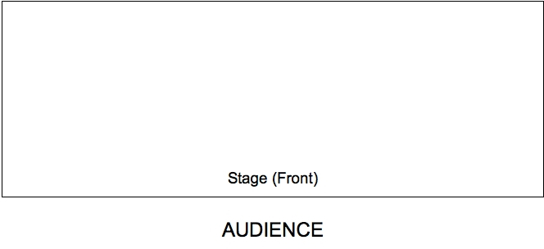

DRUMS/ CONGAS/ VOX

KEYS
BASS / VOX
GUITAR

