HIFI CLASSICS BY
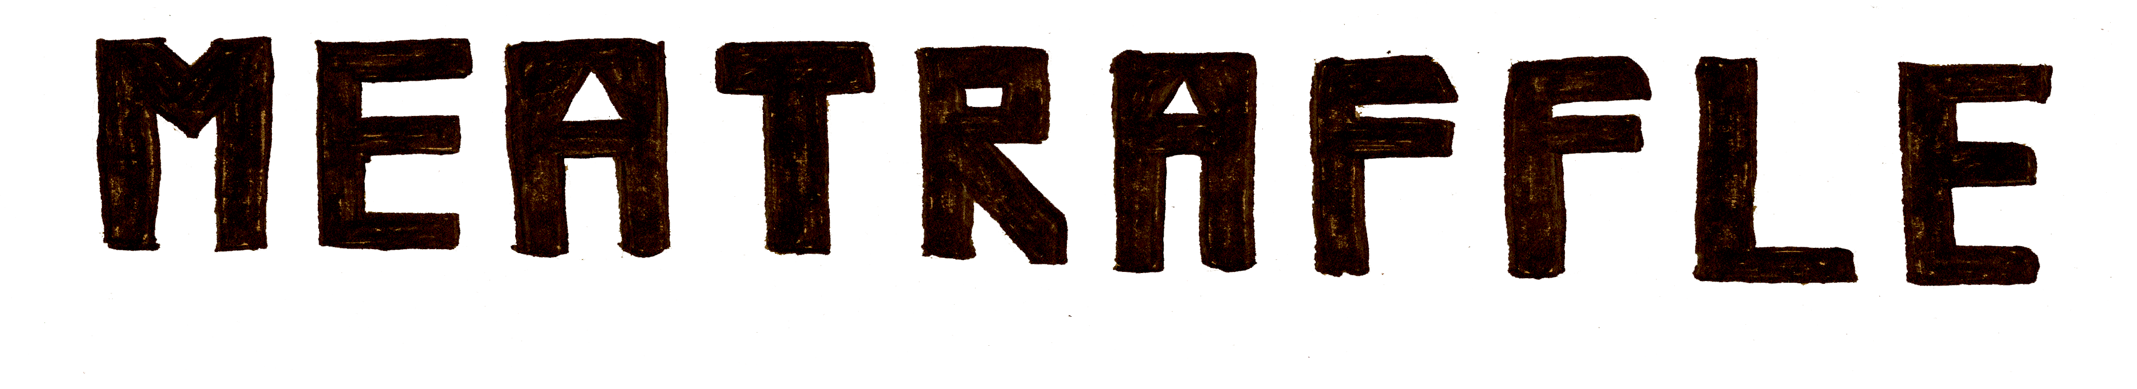
RELEASED FRIDAY THE 13TH OF NOVEMBER ON TRASHMOUTH RECORDS

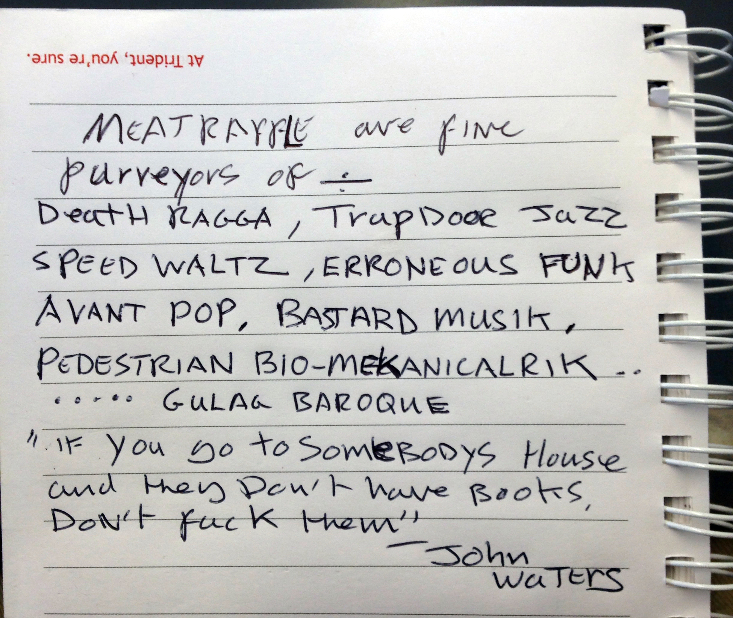

“WHEN MEATRAFFLE FIRST STARTED, I USED TO SAY THEY WERE MY FAVOURITE BAND AS A JOKE. NOW THEY ACTUALLY ARE MY FAVOURITE BAND”
- LIAS SAOUDI (FAT WHITE FAMILY)

MEATRAFFLE TESTAMENT

“For the last 2 years we have sung songs under the banner of MEATRAFFLE. If we had to begin it all over again we would, of course, try to avoid this or that mistake, but our main course would have remained unchanged. We shall die as proletarian revolutionists, dialectical materialists and consequently, irreconcilable atheists, our faith in the communistic future of music is not less ardent. Indeed it is firmer today than it was in the days of our youth. Madonnatron has just come up to the studio window and opened it up wide, so that the air may enter in more freely. I can see a bright green ship below the wall and a clear blue sky above the wall, and sunlight everywhere! Life is beautiful. Let the future generation cleanse itself of corporate indie, false metal, Britpop and x-factor, and enjoy it to the full.”

“DEATH RAGGA - TRAPDOOR JAZZ - SPEED WALTZ –
ERRONEOUS FUNK - AVANT POP - BASTARD MUSIK –
PEDESTRIAN BIO MEKANICALRIK - GULAG BAROQUE”

PRODUCED BY LIAM D MAY &
MIXED BY LIAM D MAY & LUKE E MAY AT TRASHMOUTH STUDIOS

MEATRAFFLE WILL BE SUPPORTING FAT WHITE FAMILY ON THEIR UPCOMING UK TOUR
LISTEN TO HIFI CLASSICS HERE…
https://soundcloud.com/trash-mouth-records/sets/meatraffle-hifi-classics/s-GbS3T
http://www.facebook.com/meatraffle
Contact: luke@trashmouthrecords.com
