Myles Henderson – Vocals / Electric Guitar
Connor Hanly – Vocals / Electric Guitar / Acoustic Guitar / Harmonica
Jordan Critchon – Backing Vocals / Bass Guitar
Joe Buttrick – Drums
Twisted Revolution can provide:
Drum breakables inc:
- Drum Stool
- Sticks
- Snare Drum
- Snare Stand
- Kick Pedal
- Hi – Hat Body/Clutch
- Cymbal Stands (3)
- Cymbals inc. Hi-Hats, Crash (2) , Ride
- Bass Guitar
- Bass Cab consisting of 1 or 2 speakers and Amp head
- Electric Guitars (2)
- Guitar Amps (2)
- Acoustic Guitar
- Harmonicas
- Effects Pedal Board
- Guitar stands
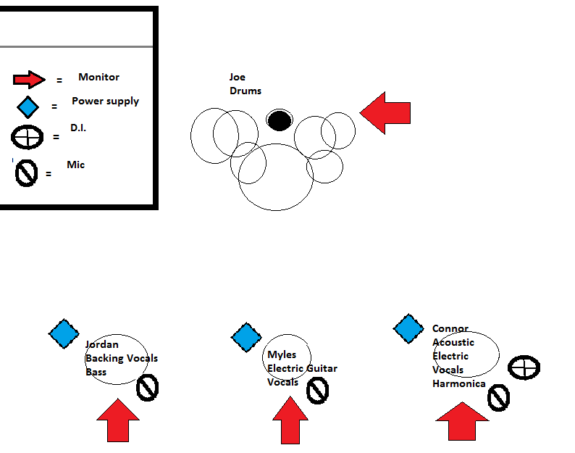
- Cables for all above devices

https://soundcloud.com/twisted-revolution-1
https://www.facebook.com/Twisted-Revolution-130095377068196/?fref=ts
Thank you

