**[](http://www.changmusic.com)**

**DJ | Producer |REMIXER**

London DJ now based in Germany, on continuous worldwide tour

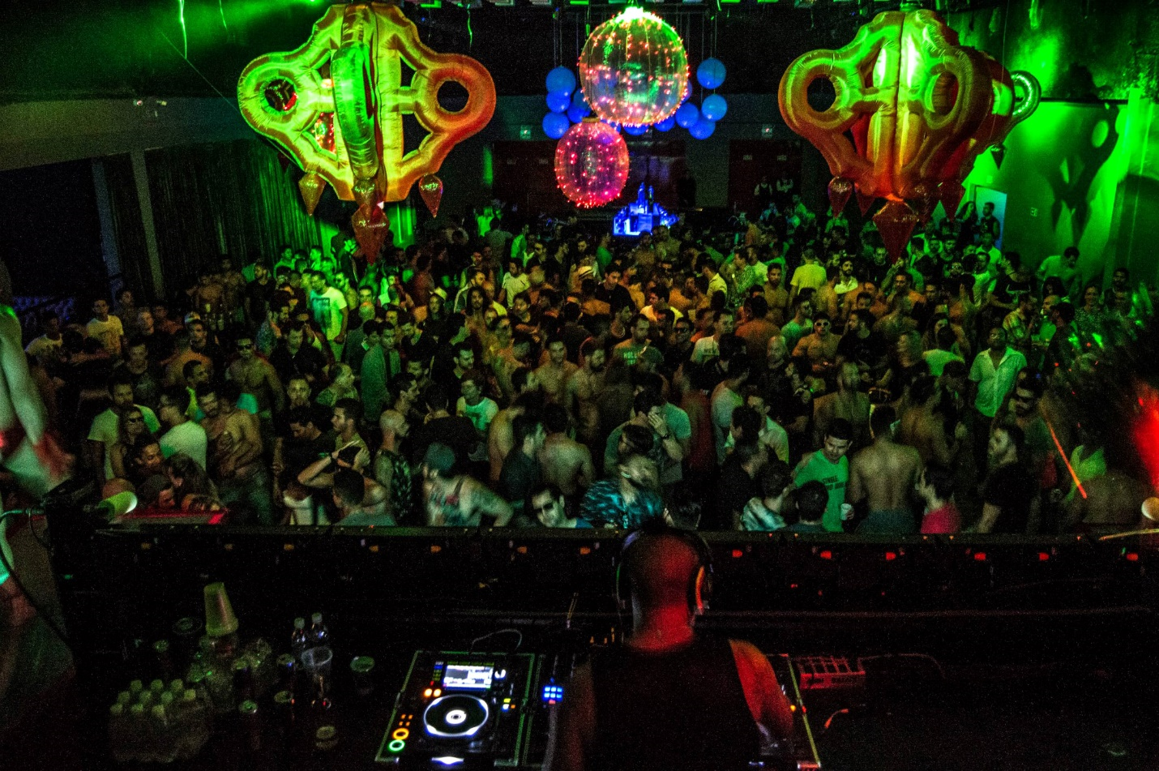

Live in Brasilia, July 2015

[](http://www.facebook.com/djjackchang.officialfanpage) [facebook.com/djjackchang.officialfanpage](http://www.facebook.com/djjackchang.officialfanpage)

[](http://www.soundcloud.com/changmusic) [soundcloud.com/changmusic](http://www.soundcloud.com/changmusic)

[](http://www.twitter.com/djjackchang) [twitter.com/djjackchang](http://www.twitter.com/djjackchang)

[](http://www.linkedin.com/in/djjackchang) [linkedin.com/in/djjackchang](http://www.linkedin.com/in/djjackchang)

[](http://www.youtube.com/user/changmusic) [youtube.com/user/changmusic](http://www.youtube.com/user/changmusic)

**Profile**

Born in London, and trained in classical music for eleven years (music theory, piano, violin), Jack's success is not due to a single style – his musical acrobatics have achieved performances in energetic vocal sets such as Rapido (Amsterdam) and WE Party (Madrid), whilst also keeping the crowds at the biggest fetish events in Europe PiG, Hustlaball (Berlin, Las Vegas, NYC), Black Party (Zurich) thrilled with his darker tribal beats. His live sets have taken him worldwide to The Endup (San Francisco), JumP (Taipei), Club Angel (Shanghai), Taboo (Singapore), Mighty Asia (Bangkok), Trouble (Dubai), Sydney Mardi Gras, Stereo (Montreal), VD+ (Mexico City), White Party (Miami), His clockwork mixing technique has both delighted and thrilled dance addicts, and drawn both admiration and envy from fellow DJs around the world. In January 2013 Jack was also awarded Best DJ 2013 by the first X-Awards in Europe.

The most recent highlights include: Residencies in Rapido (Amsterdam), DIESEL / KLUSTER (Madrid), guest appearances at PAPA (Guangzhou, Shenzhen), Karmabeat (Mexico City), Revolution (Rio de Janeiro, Brasilia), BlackKnight (Montreal), ARENA Festival (Playa del Carmen), Pitbull (Vienna), BEEF (Tel-Aviv), Black Party (Zurich), Jungle (Atlanta), headlining Bal en Cuir (Leather Ball) at Black & Blue 2012 (Montreal), and in 2013 also headlined both PiG Berlin (Folsom Europe) and Magnitude (Folsom Street Fair) in 2013.

Jack is currently awaiting the release of his first official remix through ALTAR & Jeanie Tracy “Andale” set for release on 13 October through iTunes and is currently in the studio working on remixes for Amuka, and Sybil, with more unofficial remixes and productions on the way!

**Promotional Photos**

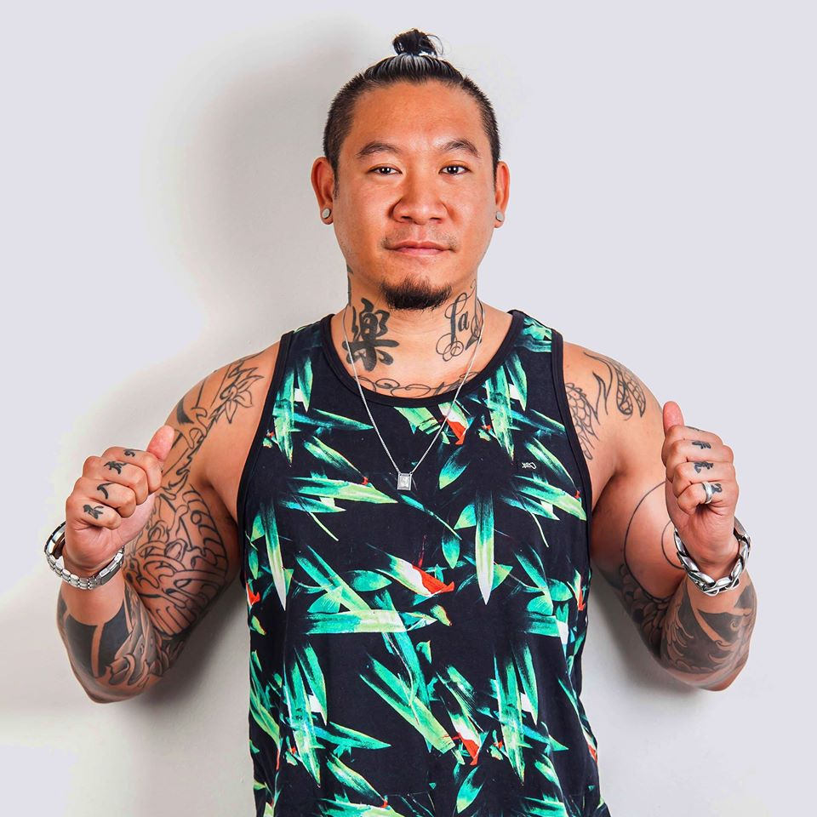 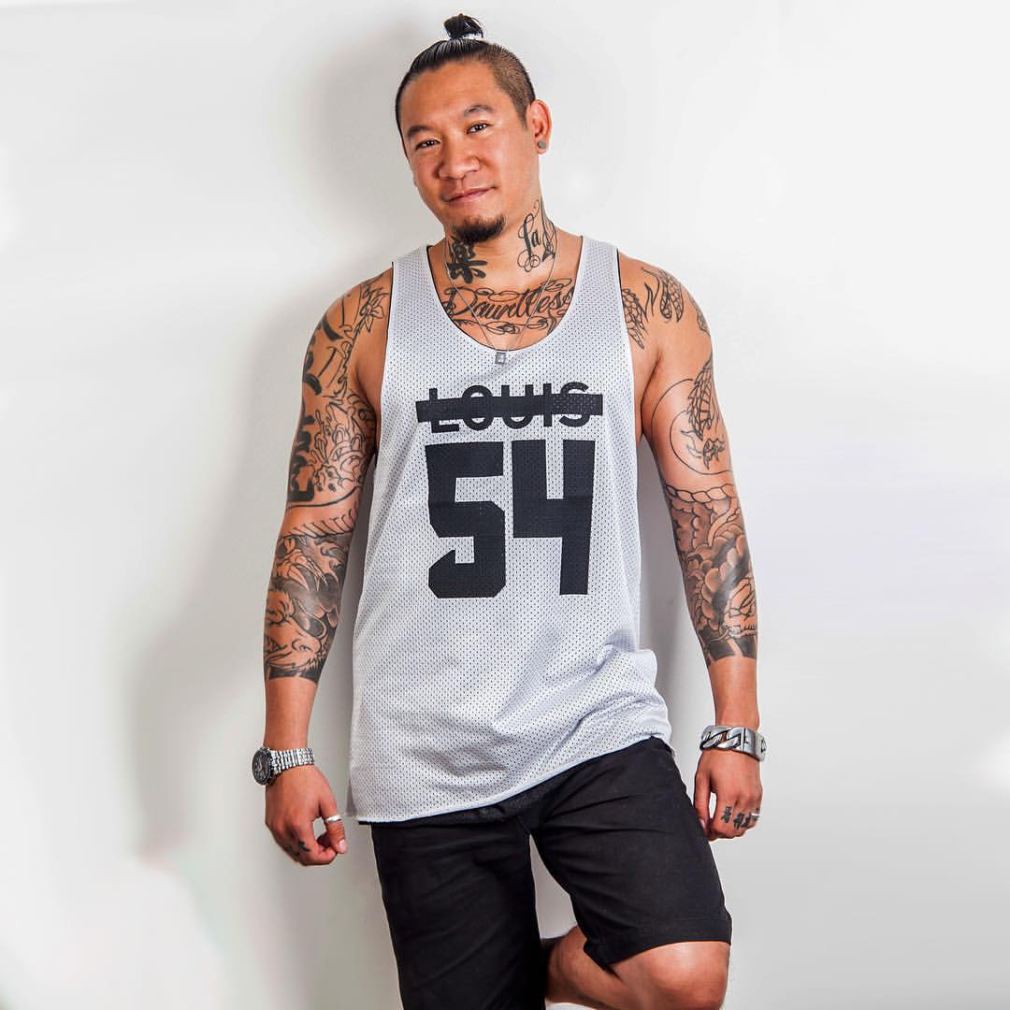

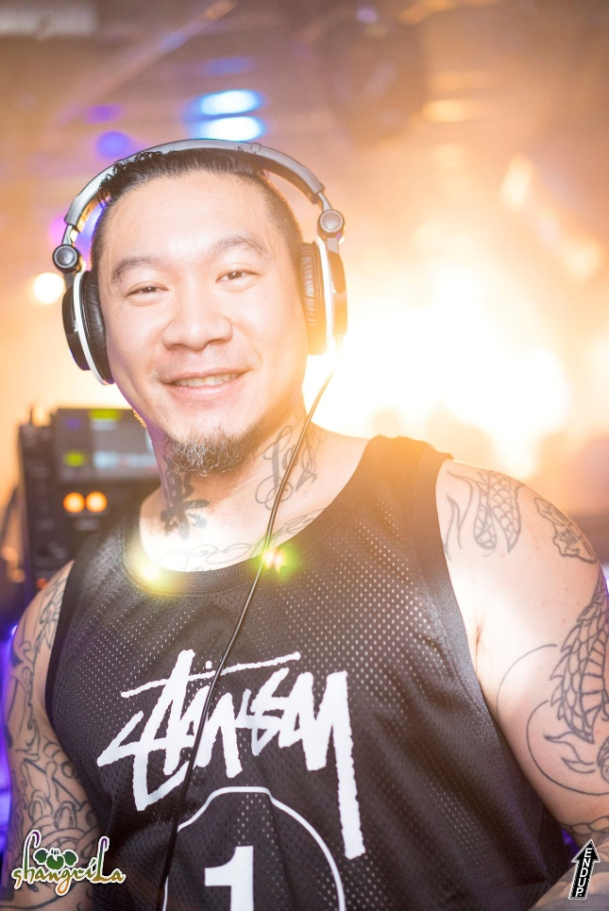 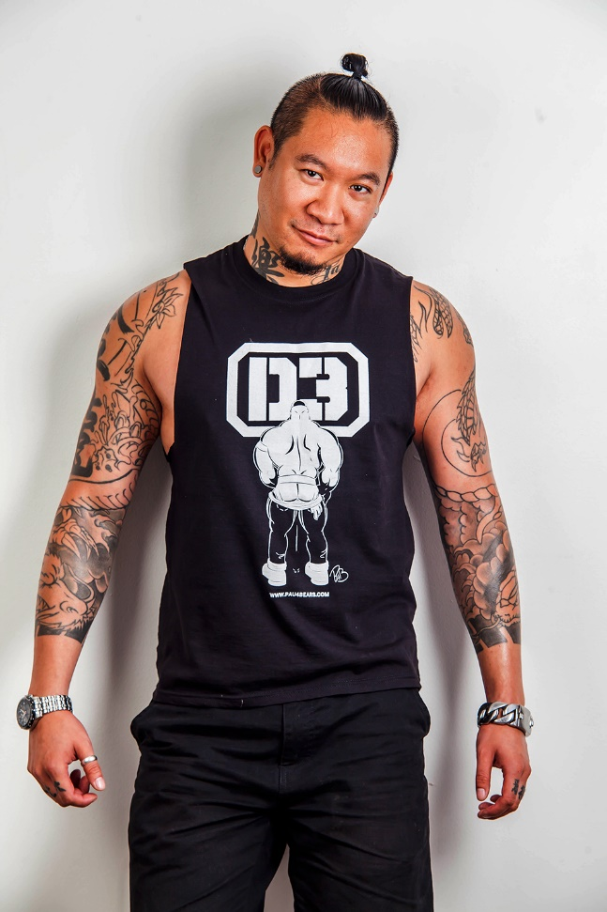

**Tour History (in no particular order)**

**United Kingdom** London, Manchester   
http://www.changmusic.com/images/flags/de.gif **Germany** Berlin, Cologne, Hamburg, Leipzig   
http://www.changmusic.com/images/flags/us.gif **United States** Las Vegas, Palm Springs, Los Angeles, Dallas, New York, San Diego, San Francisco, Provincetown, Chicago, Atlanta  
http://www.changmusic.com/images/flags/br.gif **Brazil** Rio de Janeiro, Brasilia   
http://www.changmusic.com/images/flags/cn.gif **China** Shanghai, Hong Kong SAR, Guangzhou, Shenzhen   
http://www.changmusic.com/images/flags/ae.gif **United Arab Emirates** Dubai   
http://www.changmusic.com/images/flags/pt.gif **Portugal** Lisbon   
http://www.changmusic.com/images/flags/nl.gif **The Netherlands** Amsterdam   
http://www.changmusic.com/images/flags/be.gif **Belgium** Brussels, Antwerp   
http://www.changmusic.com/images/flags/es.gif **Spain** Madrid, Barcelona, Canary Islands   
http://www.changmusic.com/images/flags/it.gif **Italy** Rome, Naples   
http://www.changmusic.com/images/flags/se.gif **Sweden** Stockholm   
http://www.changmusic.com/images/flags/dk.gif **Denmark** Copenhagen   
http://www.changmusic.com/images/flags/fr.gif **France** Paris, Strasbourg   
http://www.changmusic.com/images/flags/il.gif **Israel** Tel-Aviv   
http://www.changmusic.com/images/flags/th.gif **Thailand** Bangkok   
http://www.changmusic.com/images/flags/au.gif **Australia** Sydney   
http://www.changmusic.com/images/flags/ca.gif **Canada** Montreal, Toronto   
http://www.changmusic.com/images/flags/tw.gif **Taiwan** Taipei   
http://www.changmusic.com/images/flags/at.gif **Austria** Vienna   
http://www.changmusic.com/images/flags/mx.gif **Mexico** Mexico City, Playa del Carmen   
http://www.changmusic.com/images/flags/sg.gif **Singapore** Singapore   
http://www.changmusic.com/images/flags/ie.gif **Ireland** Dublin



**Promotional Artwork**

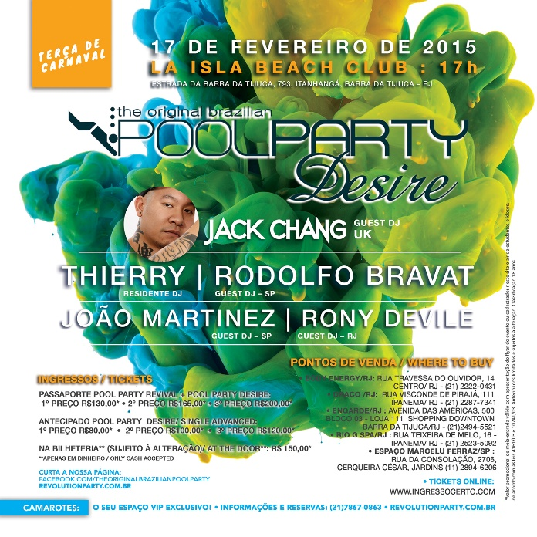 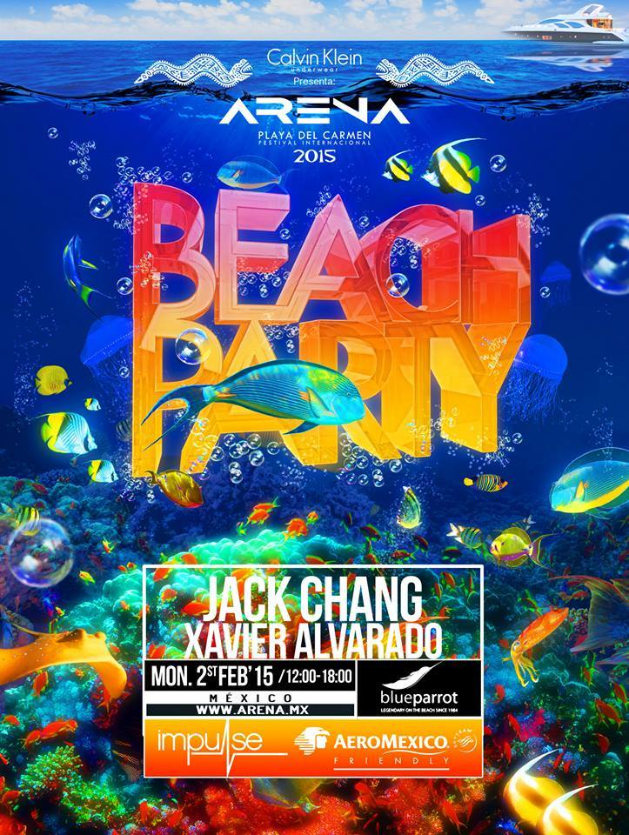

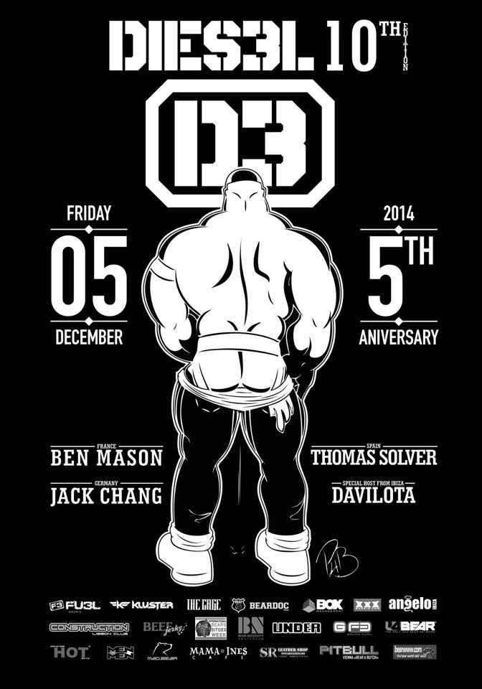 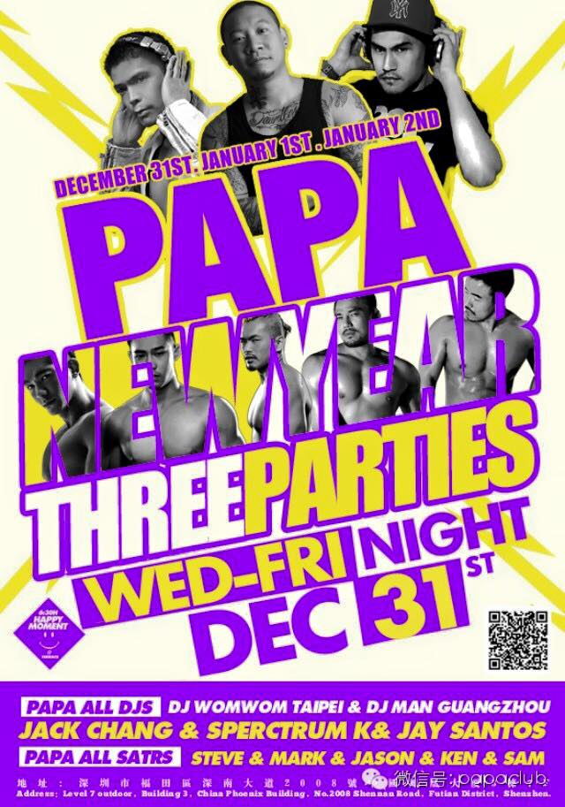

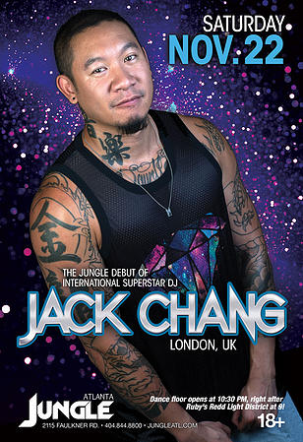 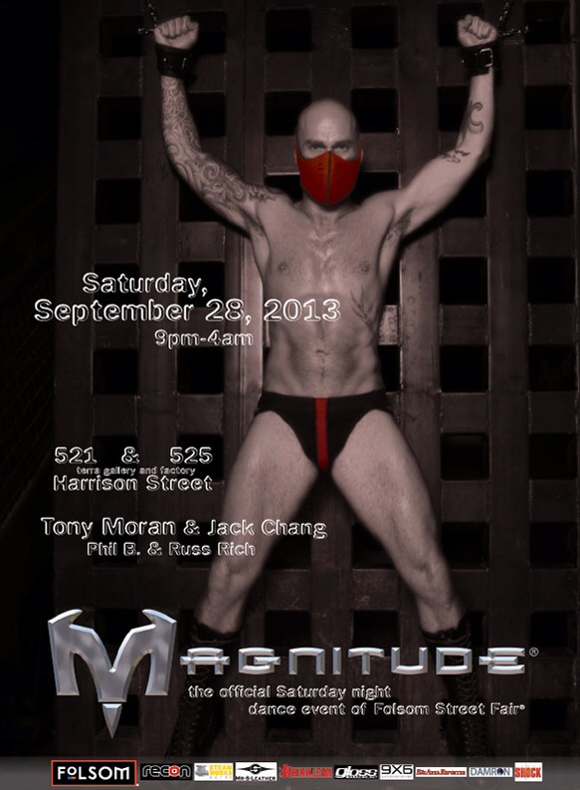

 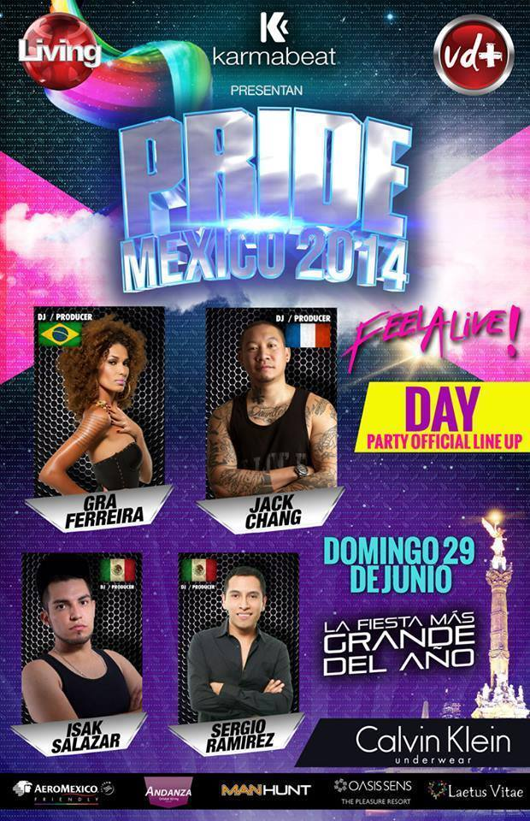

**Contact**

For North American bookings please contact:

DFL Management (**Patti Razzeto**)

[dflmanagement@me.com](mailto:dflmanagement@me.com)

Tel. +1 213-219-0319 (USA, PST)

Talented (**Victor Mauro-Rogers**)

[talented@me.com](mailto:talented@me.com)

Tel. +1 954-401-0908 (USA, EST)

For all Brazil and South American enquiries please contact:

Elder Morenno Talent Agency (**Elder Morenno**)

[eldermorennodjs@gmail.com](mailto:eldermorennodjs@gmail.com)

Tel. +55 11 9 87219154 (BR, EST)

For all European and enquiries in other territories please contact:

**Rudi**

[management@changmusic.com](mailto:management@changmusic.com)

Tel. +34 658 63 94 55(ES, EST)