Press Release - Richard Morris
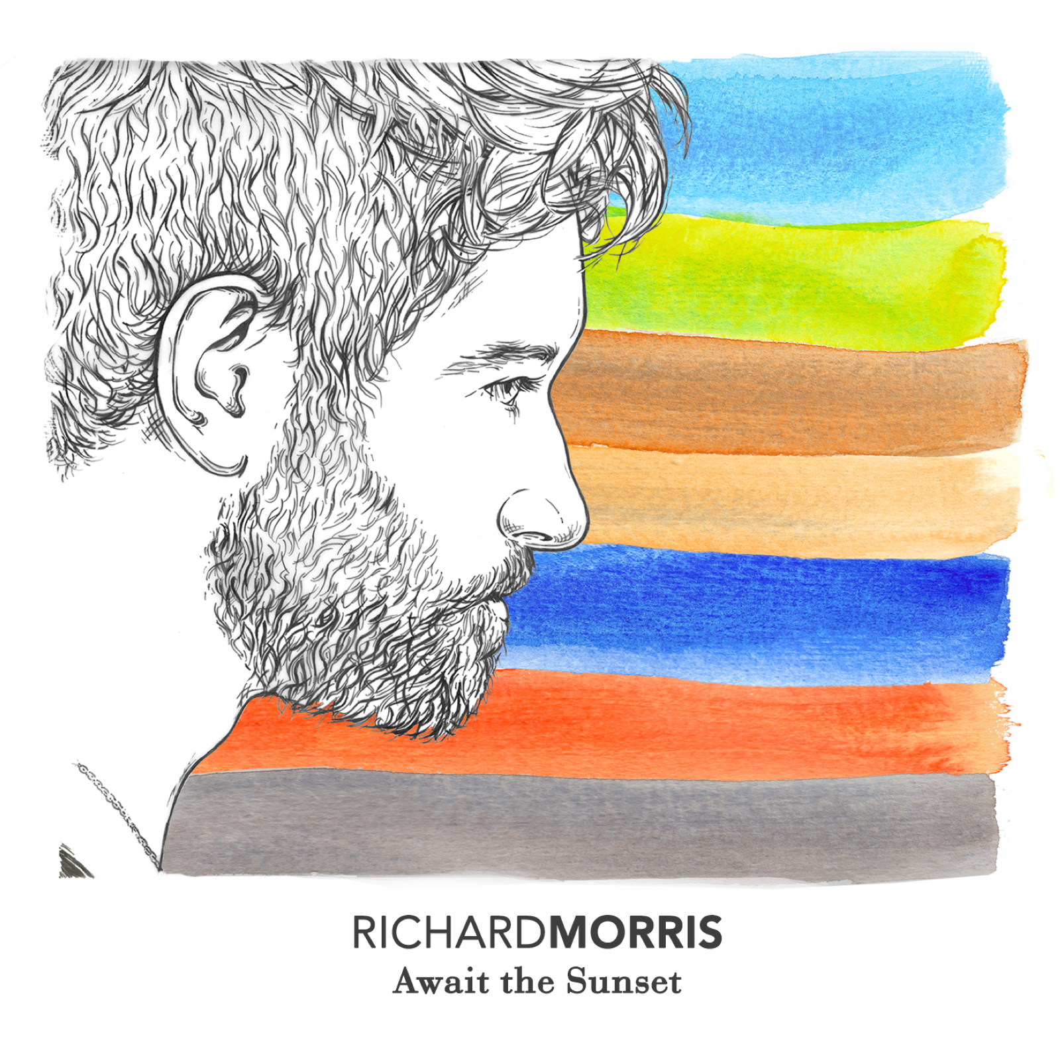
Artist Name: Richard Morris
City: Isle of Wight / Portsmouth
Current Location: Portsmouth

Contact: Andy Whittle , Management
Phone: +44 (0)208 540 4242

Genre: Singer-Songwriter, Pop

Similar Bands: Gavin DeGraw, Jack Savoretti, Fraser, A. Gorman

Discography: “Await the Sunset EP”
Released: August 14th 2015

_________________________________________________________________

Soundcloud: https://soundcloud.com/richardmorrismusic/sets/richard-morris-await-the-sunset-ep/s-gRim3

Website: www.richardmorrismusic.com
Facebook: www.facebook.com/richardmorrisofficialmusic
Twitter: www.twitter.com/rmorrismusic
Instagram: www.instagram.com/richardmorrismusic
Youtube: www.youtube.com/richardmorrismusic

Live Show Reel: https://www.youtube.com/watch?v=jgnRIp1Qtu4
Live Oak Session: https://www.youtube.com/watch?v=3q8iI-YQqYw
European Tour Reel: https://www.youtube.com/watch?v=b7gErI7-4oE

Next Headline Show: The Wedgewood Rooms, January 15th 2016

Other Details: I released my EP independently with Andy Whittle from Absolute Label Services. He's my digital co-ordinator and a very lovely chap!

With sales in 15 countries, iTunes featured my debut EP "Await the Sunset" for a massive 8 week running on their New Music Page, Singer Songwriter Page and Apple Music's Singer Songwriter Page. I've been a Surf Instructor travelling the world for the last 6 years who has recently exchanged the glorious lifestyle of palm trees, coconut water and endless sun for the cold rainy isles to give my music the best possible chance I can!

I've had radio plays on BBC Radio Solent ('What is Love' single premiere), BBC Isle of Wight Radio (winner of record of the week), Express FM & Source FM. I am also going to featured on Noel Edmunds brand new radio show 'Positively Talented' on their preview show before it goes lives on November 16th.

I've just finished a European Tour across Spain and France sponsored by Star Surf Camps with my 7 piece band and in April I sold out a Headline Show in Portsmouth to celebrate my band launch. I'll be returning back to Portsmouth January 15th to headline The Wedgwood Rooms.

Track 3 of the EP 'Amazingly Fantastically Beautiful" was featured by the hugely popular London Instagram account (1.5 million followers) for a promotional video they produced for Eurostar and the connection line between London & Marseille.

Our official music video for our single "What Is Love" is currently being pitched to VEVO by Absolute Label Services and is due for release January 15th 2016.



