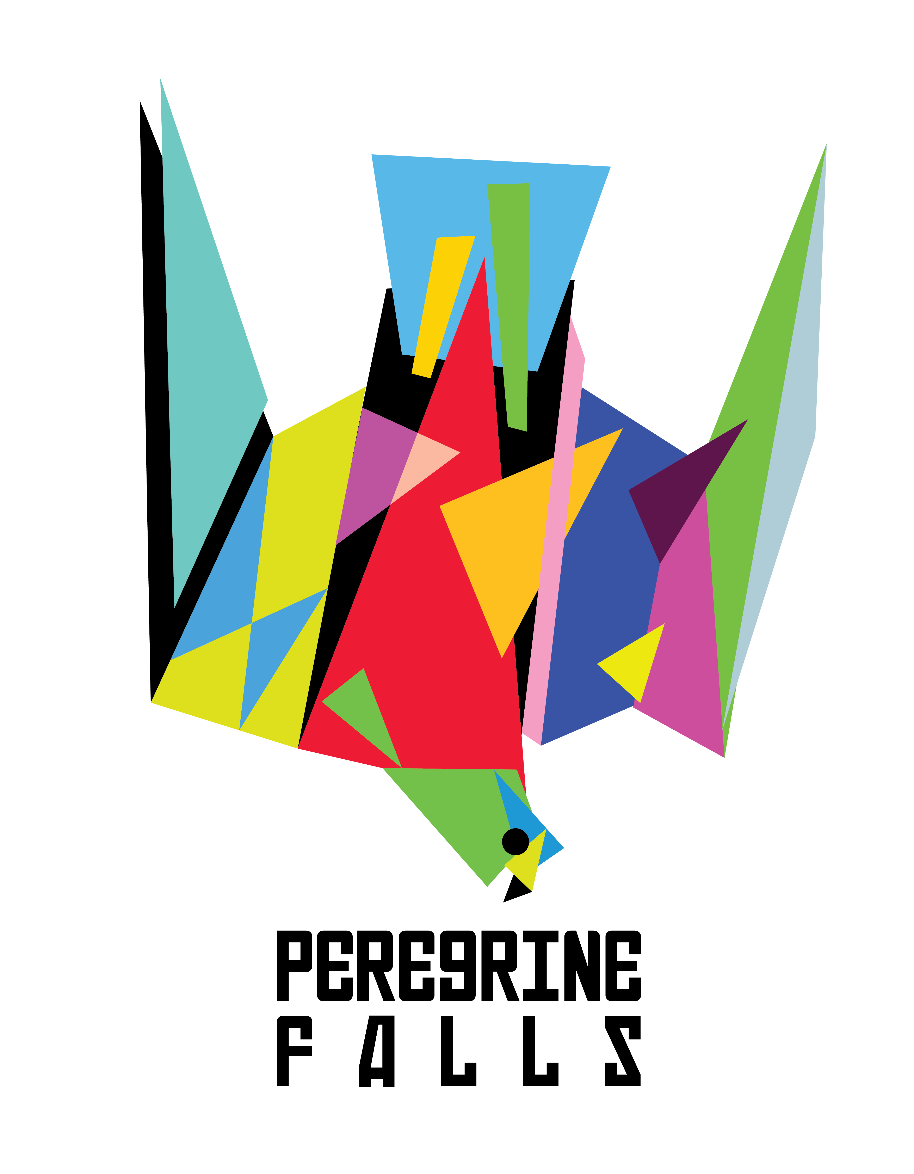

Peregrine Falls is a hard line musical response to this host we call earth. Call it NeckPunch. FreePunk. Peregrine Falls is Kenton Loewen & Gordon Grdina. Vancouver, Canada is home. Drums and guitar. Dead Kennedys to Ornette Coleman. Their debut EP “Two Fish” is available September 8, 2014. Debut LP expected 2016.

Grdina and Loewen tease out the heavy handed improv with sticks and guitar strings. Lacerating riffs curl out like black smoke, drums tumbling erratic like a head-on locomotive collision. Witness inspired expertise in the form of mathy sludge.

“The fastest animal in the world is the Peregrine Falcon. It is known for reaching record speeds upwards of 300 km/h. Its hunting methods and sheer ability for velocity make it a fascinating animal but what really captured our attention was one of its unique hunting behaviours. Before the Peregrine Falcon executes a dive-bomb attack, it seems to almost fall from its normal flight pattern, as if in a moment of stasis. Hence the name, Peregrine Falls. To us, the Peregrine’s fall denotes the moment of beautiful uncertainty in improvisation where one takes a focused leap in to the unknown and, with that, we give you Peregrine Falls.”

Think —> DFA 1979, Ed Blackwell, Shellac, The Thing, Jack White, Marc Ribot, Rage Against the Machine.

"a soundtrack to a Guy Ritchie film that Guy Ritchie hasn't made yet." - Brad Frenette, CBC Music

"...free yet completely focused...the last minute of the opening piece, you just want to shout, "Holy sh*t!"... it is fast and furious and tight at the same time." - Bruce Lee Gallanter, DMG, NYC
"...Modern Jazz for Metalheads..." Alexander Varty, Georgia Straight

"Peregrine Falls brutalized the basement with destructive ear-splitting muscle-jazz stomp, armed with bows, a theremin, and wacked-out mindfuck guitar solos." - Matt Williams, NOISEY

"…their hypnotic marriage of instrumental post-hardcore and avant-garde technique both enchanting and exciting." – Tom Beedham, Exclaim!

www.peregrinefalls.com
facebook.com/peregrinefalls
instagram.com/peregrinefalls
twitter.com/peregrinefalls
youtube.com/peregrinefallsmusic

