Toni Kitanovski Trio
Band members:
Toni Kitanovski – Guitar
Vasil Hadzimanov –Hammond Organ
Aleksandar (Alex) Sekulovski – Drums
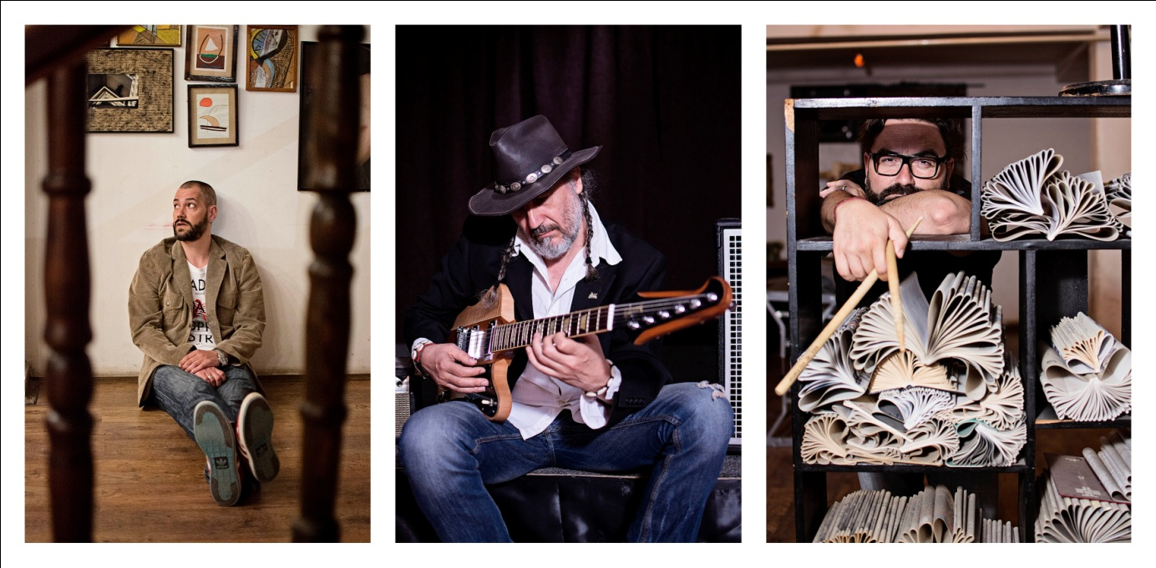
The musicians in this trio have shared stage and been friends for many years. They also share the same musical interests in all things African, contemporary aesthetics and free flow interaction.
Toni Kitanovski likes to describe himself as a composer who plays the guitar.
He has worked and performed with jazz legends like Charlie Mariano, Vinny Golia and Greg Hopkins amongst others; joined Derek Trucks, Steve Bernstein’s Sex Mob on stage, but lately he’s best known for his ongoing collaboration with the gypsy brass band Cherkezi. He has also collaborated with the Macedonian Symphony and Slovenian Radio Big Band Orchestra.
Ten years spent in Boston, thanks to a full Berklee scholarship, were filled with unique and extreme musical discoveries that now shape the color in his musical voice. There he met Vasil Hadzimanov, who's been Toni’s first choice of pianist and keyboardist ever since. Moving back to Europe and his native Macedonia required some adaptation. The exotic sounds of the multi-cultural fabric of Boston, where traditional music from every imaginable part of the world can be found around the corner anytime needed, were substituted with equally intriguing Balkan variety of musical colors based on modes and rhythms of antiquity, byzantine and eastern traditions.
Drummer Aleksandar (Alex) Sekulovski completes this trio. He has been at the heart of all of Toni’s projects for many years. Aside from his special interest in the history of jazz drumming, he is also an accomplished composer for theater, having won the Gran Prix for Music from the Moscow Theater Festival, among other awards.
For further info, please contact:
vangel.vlaski@propermusicgroup.com

