**Links**

[www.memorysplice.com](http://www.memorysplice.com)

[www.soundcloud.com/memorysplice](http://www.soundcloud.com/memorysplice)

[www.mixcloud.com/memorysplice](http://www.mixcloud.com/memorysplice)

[www.facebook.com/memorysplice](http://www.facebook.com/memorysplice.com)

[Memory Splice (@MemorySplice) | Twitter](https://twitter.com/memorysplice)

**Press/Media**

<http://www.globaltrance.pl/Czytaj,Szczegoly,3,5717,0.html> Feature Interview Globaltrance.PL <http://www.musicmetamorphosis.com/meet-sonny-pixie-bruner-better-known-memory-splice>

<http://djsmagazine.pl/gazeta.php?id=58#close> Pages 33-34 Interview with Polish DJ Magazine

[http://soundtraffic.pl/memory-splice](http://soundtraffic.pl/memory-splice/) Interview with SoundTraffic

<http://www.pharmacymusic.com/pharmacy-singles-getting-major-love-from-djw-mag-en-espanol/> DJW Magazine coverage Argentina

**Short Bio for Event Pages/Sites/ect**

Memory Splice is Atlanta based trance and electronic music production/live performance DJ group. First signed to Christopher Lawrence's label Pharmacy Music and featured by electronic music icon Paul Van Dyk, their debut EP, ”Vermillion/Antropy” spent 28 straight days on the Beatport Top 100 Trance Release chart, peaking at #16, Memory Splice is based around husband and wife team Pixie and Sonny Bruner. Their 2nd release, “Esse Quam Videri” on TFB Records, with remixes from Eshericks and Renato Dinis, debuted at #16 on the Beatport Breaks Chart and #47 on the Trance release charts. They use intense sound design and big sound palettes, layers upon layers, mind-warping automation and effects to only further showcase their talent for strong melodic uplifting or aggressive tech-heavy electronic music, music that blurs and transcends genres and subgenre. No genres, no limits, just great electronic music. Always pushing ahead embracing modernism, these artists work in harmony to bring together and burn the bridges of classic and progressive trance and house using controllerism and all that technology can offer and will offer, to create and recreate a time-bubble of when listening to Electronic Music and going to underground parties and clubs was an immersive, communal, and intense listening and dancing experience.

They are supported by noted dance music DJ/Producers including Paul Oakenfold. M.I.K.E. Push, Guiseppe Ottaviani, French Skies, Photgrapher, Suzy Solar, Karybde & Scylla, Christopher Lawrence, Talla 2XLC, Thomas Datt, Paul Trainer, Kaeno, Allen & Envy, Liquid Soul, Paul van Dyk and more. Memory Splice are resident DJs at SoundTraffic in Poland/Berlin. They do a two monthly global broadcasts called "Soundscapes" and are currently finishing upcoming EPs and other projects. Their most recent non-dance music release was the original score and audio engineering for the audio chapbook “Darkly Told” by American poet Alicia Cole. TFB155 Skylex’s “Pocket Rockets” features a Memory Splice Rebuild and hit Beatport October 22, 2015 and TFB158 “Ratcatcher (ft. Alicia Cole and CSE Cooney)”, featuring remixes by tech-trance and psytrance stars Stephane Badey and Changes is their third original EP and comes out November 2nd.

**Long Bio**

The production team known as Memory Splice is the musical union based around partners Sonny and Pixie Bruner. These two artists have over 35 years combined as performers, composers, arrangers and producers. Memory Splice seeks to take electronic dance music into all the far and distant imagined futures.

Released October 14, 2013 and having been featured on Christopher Lawrence’s “Rush Hour”, Paul Van Dyk’s VONYC Sessions”, Kaeno’s “Perspectives”, Tero A’s “Northern Skies, other Trance and Progressive EDM radio shows and in many playlists, their debut EP “Vermillion/Antropy on Pharmacy Music hit #16 on the Beatport Trance Release chart and remained in the Top 100 for 28 days.

Thier second EP "Esse Quam Videri" (July 17, 2015), remixed by Renato Dinis and Eshericks, on Spain's TFB Records was a repeat success and was on the Beatport Trance Release Top 100 and the Breaks Released Top 100 charts simultaneously debuting at #46 for Trance and # 16 for Breaks. It was also #1 on the Weekend Breaks Breakbeats chart. It was in the sets of many live sets and podcasts. It was featured twice on the legendary Paul Oakenfold's "Planet Perfecto" radio show (Episodes #237 and #249)

Their EPs have had support from Champa, A.R.D.I, Photographer, Christopher Lawrence, DJ Mag, Paul van Dyk, Robert Gitelman, Chaim Mankoff, Paul Oakenfold, Fergie & Sadrian, Stephane Badey, French Skies, Skylla and Karybde, Giuseppe Ottaviani, Liam Wilson, Manuel La Saux, Suzy Solar, Jens Jakob, DJ Geri, Diego Morill, Kaeno, Liquid Soul, M.I.K.E, Paul Trainer, Andrei Mircea, Phil Parry, Dan Delaforce, Tycoos, Physical Phase, Allen and Envy, Tasso, Tero A, Talla 2XLC, Thomas Datt and others.

Memory Splice uses intense sound design and big sound palettes, layers upon layers, mind-warping automation and effects to only further showcase their talent for strong melodic uplifting or aggressive tech-heavy electronic music, music that blurs and transcends genres and subgenre. It’s just bliss. Their sets are the time when everything is beautiful, the heart beats faster, and nothing hurts.

Memory Splice is always pushing ahead embracing modernism, these artists work in harmony to bring together and burn the bridges of classic and progressive trance and house using controllerism and all that technology can offer and will offer, to create and recreate a time-bubble of when listening to Electronic Music and going to underground parties and clubs was an immersive, communal, and intense listening and dancing experience.

Memory Splice is always hard at work in their Atlanta GA area studio working on their upcoming EPs and new projects, exploring new audio vistas and doing their their monthly broadcasts of “Soundscapes”, as well as live perfomance DJ'ing.

They are residents at TranceSound.net, the worlds leading Trance Portal based out of London UK, including TranceSound Festival 2013 and their new exclusive Afterhours.FM show "TranceSound Selections" whom Memory Splice was chosen to do a set with Robert Vadney for the shows launching broadcast September 17, 2015.

As of March 2014, they became resident DJ’s for Soundtraffic on both FM and internet broadcasts on European radio. They do three hour programs on the 2nd and 4th Saturday of each month for the Soundtraffic Night Session from Berlin and feature guest mixes from both international stars such as Producer/DJ Anske and others as well as rising stars on the global and local electronic dance music scene.

No genres, no limits, just great electronic music.

**List of supporter highlights**

|  |  |  |  |  |
| --- | --- | --- | --- | --- |
| Champa | Chris Herrera | Christopher Lawrence | Dave Asprey | Diego Morrill |
| Digital Basement | Franco Landriel | DJ Feel | DJ Bissen | Fergie & Sadrian |
| Giuseppe Ottaviani | Gordon Coutts | Haris C  Andski | Jonathan Allyn | Kaeno  Paul Oakenfold |
| Liam Wilson | Liquid Soul | M.I.K.E Push | Magnus | Nick Callaghan |
| Talla 2XLC | Paul Trainer | Paul van Dyk | Phil Parry | Phil Taylor |
| Physical Phase  Chaim Mankoff | Allen & Envy  Skylla and Karybde | Renato Dinis  Eshericks  Cosmic Skies | Reviews Editor [Partyflock]  Remco Leeuwenburgh [Trancesound] | Reviews Editor [Trancehub]  Oswaldo  [DJW Magazine]  Tasso |

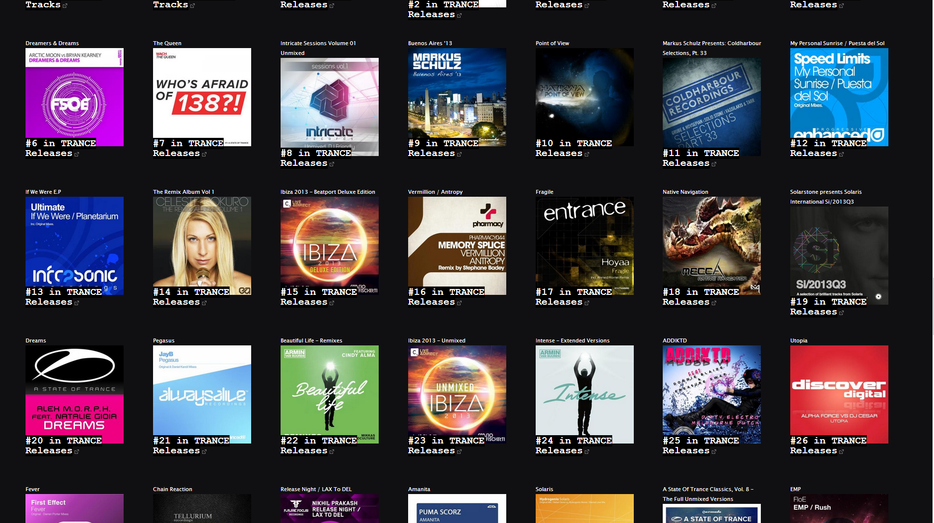

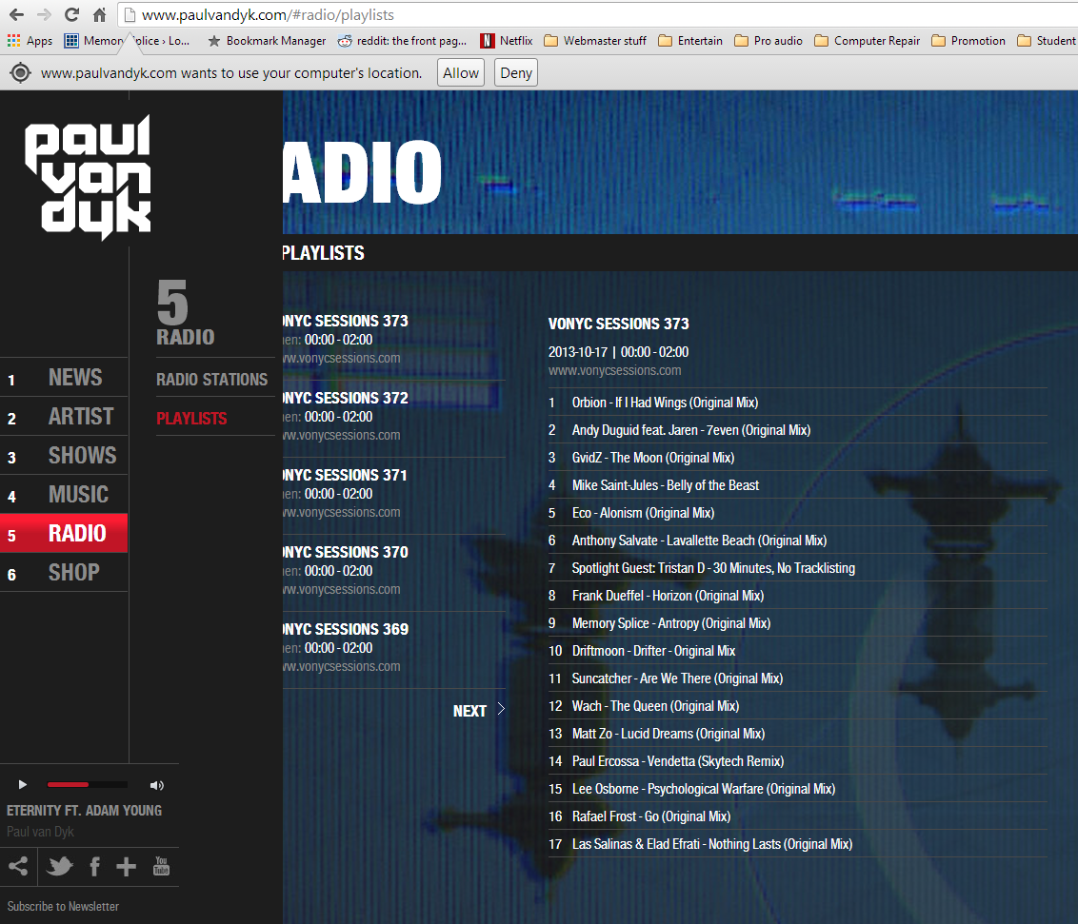

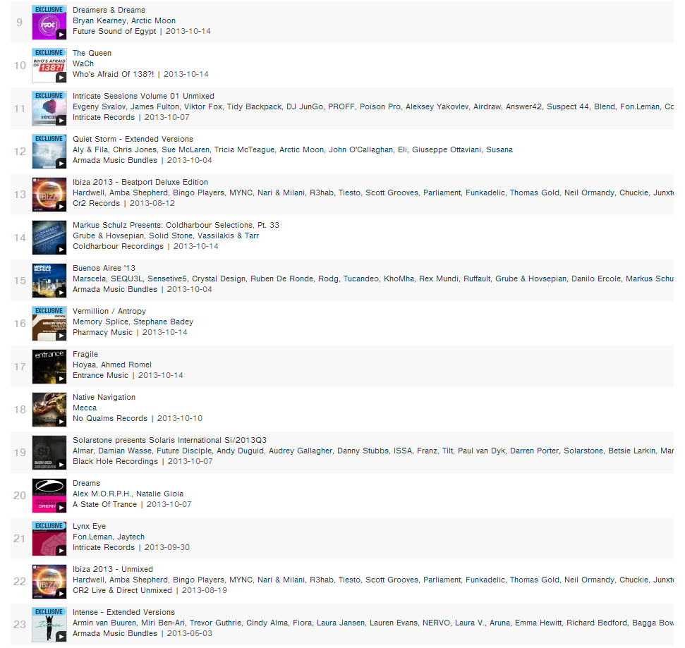

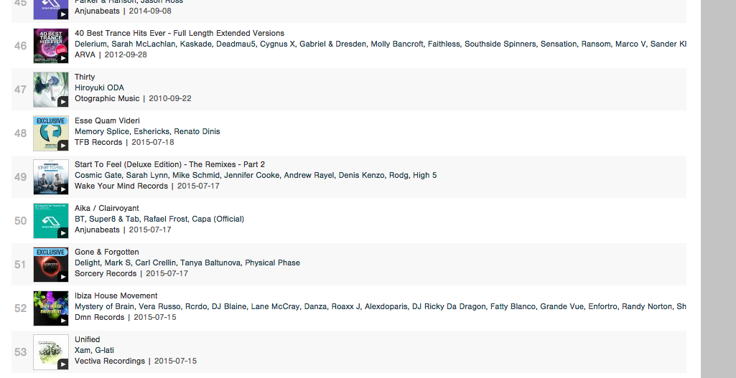

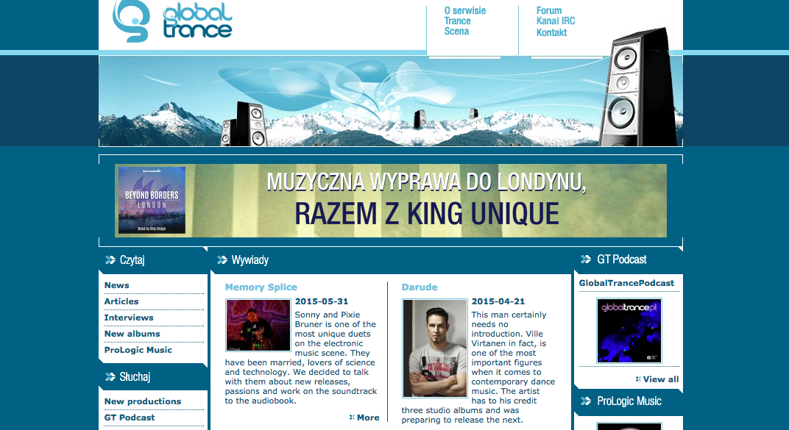

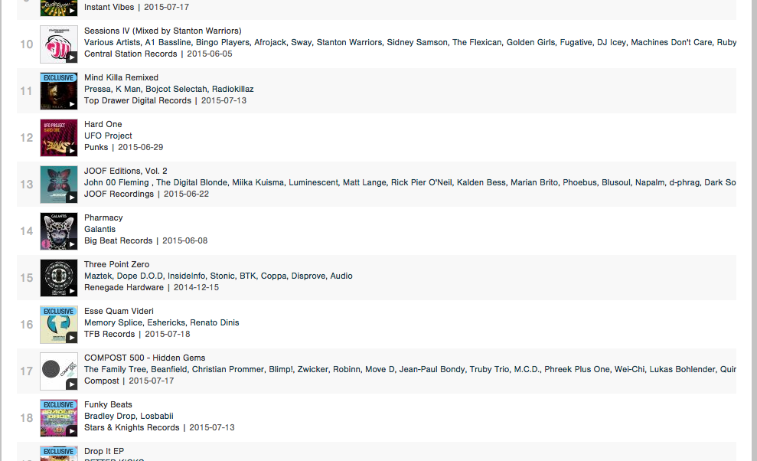

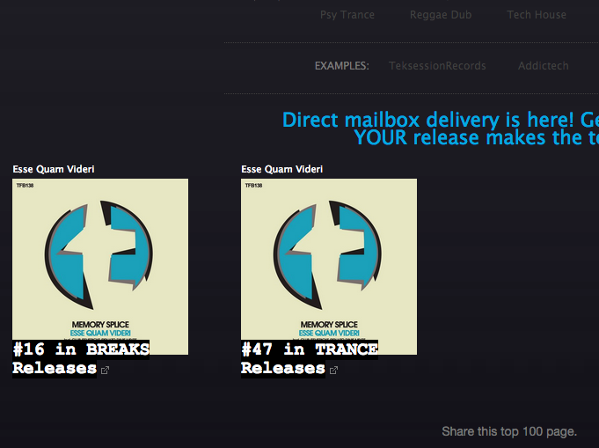

Logo

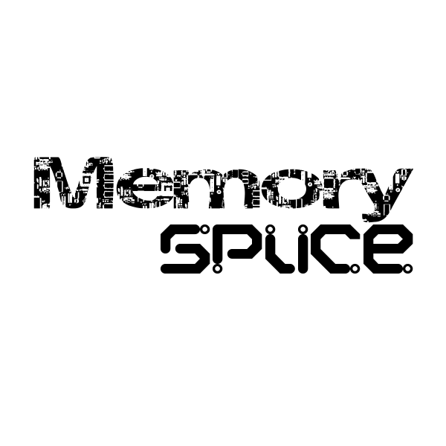

msmicah10wow.jpg

greatmelshot.jpg

msalexgreyshow.jpg

DarklyTold.jpg

NightSessionAnske.jpg

ahfmset.jpg