SEVEN MOULDY FIGS

TECHNICAL RIDER & STAGE PLAN

First of all, thank you for your interest in booking a show for Seven Mouldy Figs. Below is a list of our technical requierments. We designed this rider for optimum effectivness at the day of the show. If there are any questions or if you have trouble providing any of the below mentioned please get in touch with us before the day of the show and we will work out the solution together.

OUR STAGE SETUP IS:
1 Drumset
1 Bass Guitar
1 Electric Guitar
2 Vocals

CHANELS:
6-7 for the drums
1 for bass guitar
1 for electric guitar
2 for vocals

We assume that there is a well sizer PA system provided for the concert room with sufficient power to supply a clean and undistorted 110dB SPL RMS to the mixing desk and a powerful and feedback-proof monitor system. It is very important that the singer/guitar player, bass player and the drummer each have their own monitor speakers with separate mixes.

THE MINIMAL SETUP WE CAN PROVIDE

Drums:
- 1 bass drum pedal
- snare
- 1 cymbal stand
- full set of cymbals

Bass:
- 1 bass guitar
- 1 cable

Guitar:
- 1 electric guitar
- 1 amp (Laney 100w)*
- 2 cables
- distortion effect

MINIMAL SETUP WE NEED

Drums:
- drumset (2 toms, floor tom, bass drum)
- snare stand
- hi-hat stand
- 2 cymbal stands
- 1 chair

Bass:
- bass amp suitable for venues capacity

Vocals:
- 2 microphones (vocal/ back-vocal)
- 2 microphone stands

*In case of us not being able to bring our own guitar amp, we will inform you about the need to procure one (if possible, not Marshall).

OTHER EQUIPMENT

- 1 floor carpet (approx. 160cm x 220cm) for drums on stage
- 1 extension chord for the effects

Staff:
We will need a qualified sound engineer and a stage technician. At the moment we don't have a regular engineer, so we heavily depend on the staff on site.

Sound&lighting:
Both of our vocalist (the lead vocal and the drummer) prefer a little reverb in their vocals. Also the lead vocal prefers a short delay on the vocal.
As for the lighting, it is important during the show that the guitar players and the bass player always have enough light on stage to see the fretboard on their instruments.

Equipment sharing & soundcheck:
We don't have problems with sharing our equipment if asked before. We will need an absolute minimum of 30 minutes soundcheck, 45-60 minutes including setup would be perfect.

Arrival:
Please provide detailed directions in english two weeks before the date of the show with the complete adress of the venue and a telephone contact. We need a safe parking space available close to the venue if we use a van or a car for the arrival (will be noted). Please provide arrival, soundcheck and doors-open. The promoter or another person should be at the venue at arrival time.

STAGE PLAN

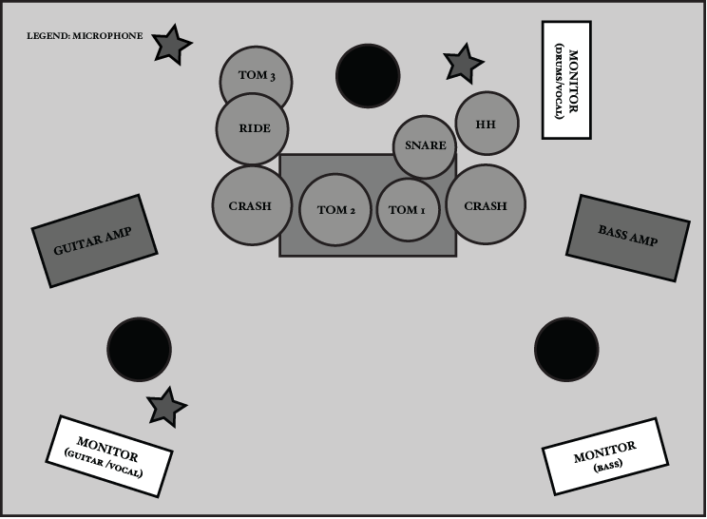.

Food & drinks:
- 3 vegan meals (no meat, no fish, no cheese, no milk, no eggs or any other animal product)
- NO finger food, sandwiches or any other food that can't be considered as a whole meal
- minimum 3 bottles of cooled water for stage
(If there are more people coming with us, it'll be noted in advance.)

Sleep:
A warm , clean and quiet accomodation for 3 (+1 or 2 if there is a driver) with mattresses, bath room and a shower. A safe parking space should be available near the sleeping accomodation (if arriving by car).

Merchandise:
If possible, a table and a small light for our merchandise in the same room as the show.

Thanks a lot for all your help. If you have any question please contact us.

CONTACT:
sevenmouldyfigs@gmail.com
Lucija Sever - (+385)099/ 322 47 37
Laura Matijašević - (+385) 097/630 82 44
Laura Tandarić – (+385) 091/785 85 52

