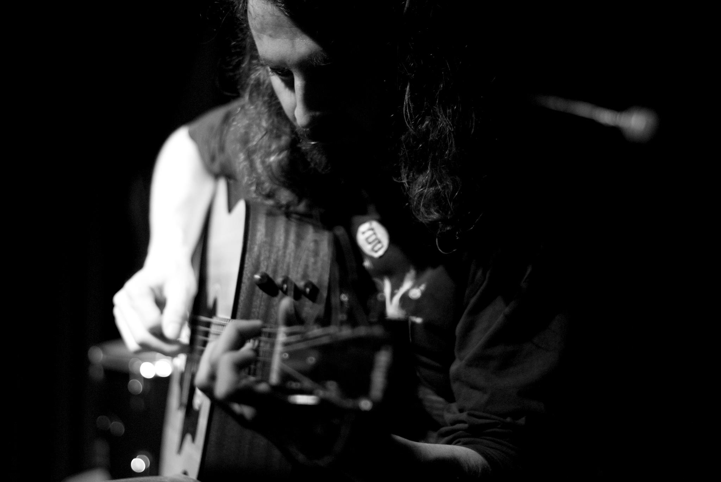

Technical Set Up

Greg only requires a DI link on stage, with two line-feeds as he will swap between his guitars during the performance. He will use a pre-amp to sort sound fine-tuning on stage.

