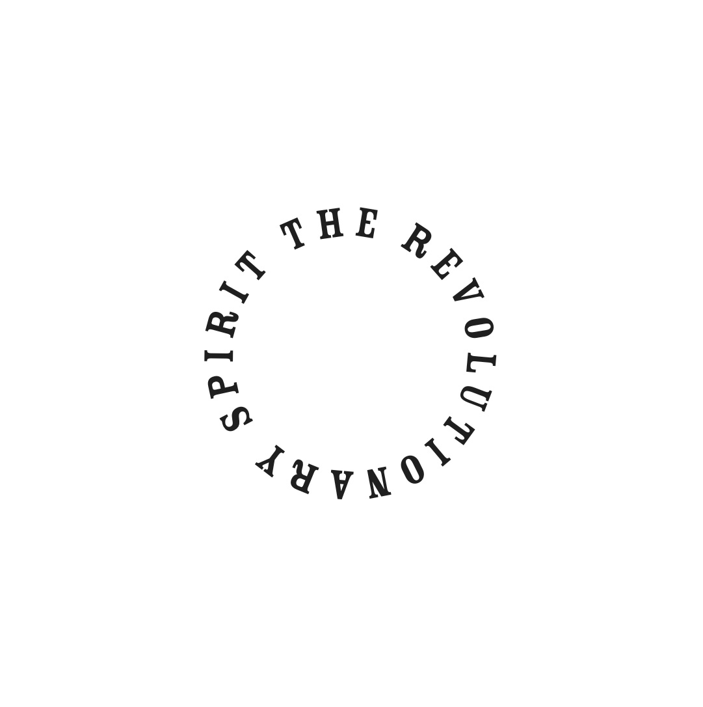
THE REVOLUTIONARY SPIRIT RELEASE DEBUT EP ‘BARROWMORE’ AND LEAD TRACK
‘LOSING MY MIND’

LISTEN/EMBED HERE: LOSING MY MIND

“Big vibes from across big stages can only be the future expectation with this band” Artrocker

North Wales based 4-piece The Revolutionary Spirit have released their debut EP Barrowmore and lead track Losing My Mind, which are available now through Bandcamp.

Following on from their 2014 limited edition 7” Sunshine/Leave It All Behind, The Revolutionary Spirit went into the studio with Simon Jones (The Verve, Black Submarine) to record debut EP Barrowmore.

The 4-track EP showcases the bands experimental sound with intense blues-rock riffs on Find My Way, a psychedelic rhythm and coy vocals on Jesus and sparse atmospheric guitars on Anytime. Losing My Mind remains minimalist amidst a swirling mass of sounds, opening with a dense bass before building into jangly guitars and a distinctive bluesy vocal.

The Revolutionary Spirit formed in 2009 in the band’s hometown of Wrexham with Josh Page (vocals/guitar), brothers James Tindle (guitars) and Jared Tindle (bass) and Greg Michell (drums).

Having toured with the likes of The Charlatans, S.C.U.M and Toy, The Revolutionary Spirit have been performing their own hometown and UK shows, which led to support and a session with BBC Wales. They will be playing shows in September and October, with further dates to follow. Full dates are below –

September:
Thurs 24th Winsford De Bees Music Bar

October:
Fri 30th Liverpool Sound Food and Drink
Sat 31st Wrexham House of Lux (Un Deg Un)

The band will be heading into the studio to record their debut album with Simon Jones this autumn.

For further information please contact Beth Parnell (Brookfield) on beth@bandwagonpress.com / 07770 637 114.

