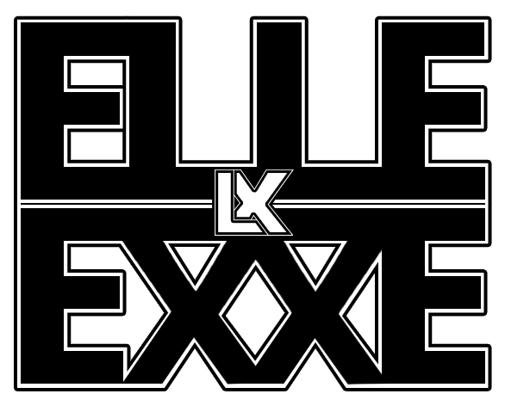

- Jack Daniels Tennessee Honey With Diet Coke for Mixer For Elle
- Crate of Beer for Band / 9-12 bottles of beer preferably Erstella Damm (Not Redstripe, Fosters or Carling)
- 8-10 bottles of water
- 5 Towels
- Galaxy Chocolate bars (original)
- Pizza from Dominos or Papa Johns – no fish!
- Heinz Ketchup

Linda doesn't drink beer that’s why the Whiskey is an alternative.

