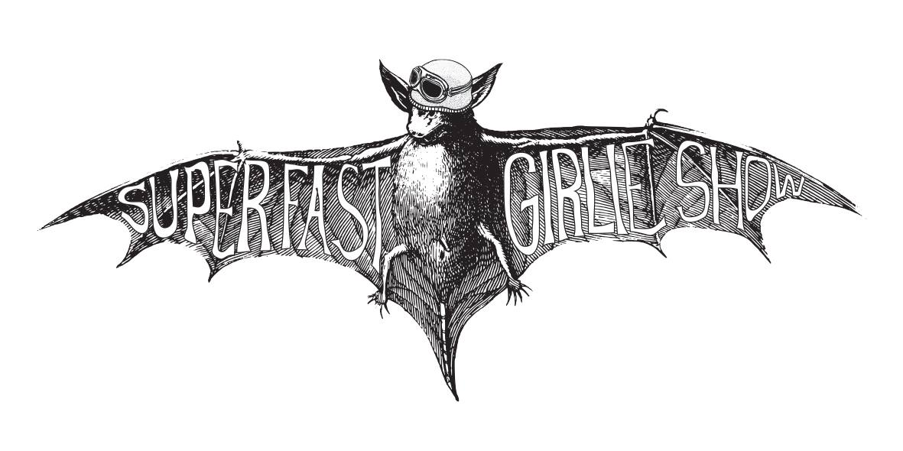
Super Fast Girlie Show ‘Don’t Go Down Gentle’
SFGS Release Date 7th August 2015

‘Don’t Go Down Gentle’ the debut album from Liverpool (UK) based low frequency noise makers Super Fast Girlie Show; the 3pc of Pasha Coxhill (Bass/Vocals), Phil Hartley (Bass/Vocals), and Allan ‘Gonzo’ Jones (Drums/Vocals) have taken their chest rattling assault on the senses to the European punk circuit – dispensing with excesses, sometimes referred to as guitars; their two-minute maelstroms of beats and noise have been likened to Motorhead meets Dr. Feelgood, and garnered both supports to the likes of Goldblade, The Damned, and Evil Blizzard as well as appearances at high profile festivals including Strummercamp, Bearded Theory, and the Rebellion Festival.

Wickedly funny, hugely heavy; Super Fast Girlie Show deliver shorter than short songs, packed with great glops of sonic reverb and cavernous bass rumbles; a head on collision of punk rock, doom metal and the blues, heavier than Napalm Death, odder than the Legendary Stardust Cowboy.

‘Don’t Go Down Gentle’

1.1980’s
2. Mind Control
3. Freaks
4. Stand Up
5. Leave It
6. I Don’t Care
7. Oh Well
8. Stones
9. Roller Derby (stole my baby)
10. Seen Enough
11. Doley Boy
12. Pub Fight

‘Don’t Go Down Gentle’ will be released at The Rebellion Festival, Blackpool, UK

Rebellion Festival, The Casbah Stage, Friday 7th August 2015 at 7.20pm
‘Don’t Go Down Gentle’ is to be released in conjunction with Antipop Records as a Digipack CD and Digital Download

Review copies of ‘Don’t Go Down Gentle as well as live and interview coverage of Super Fast Girlie Show are now available worldwide via Phil at superfastgirlieshow@gmail.com

www.facebook.com/SuperFastGirlieShow http://antipoprecords.co.uk/

‘Don’t Go Down Gentle’ – Press

Uber Rock: "as far from convention as you can get without being sectioned, aurally...two-minute cosh attacks to the base of the skull"

Mute Print: “The songs are punchier than a room full of manic heavyweight boxers…all the snorting, snarling and fuzzed up weirdness that marks out their style”

Fungal Punk “heavy duty slag noise...good pounding rhythm, a dirty incessancy...rib rattling ooze...takes no prisoners and clobbers along”

Louder Than War “Plenty of punch, lean and focussed…a more bludgeoning, fuzzy effect”

Link2 Wales “Twelve tracks smash and grab your faculties in no time at all…smashing your teeth in with big bass guitars.”

