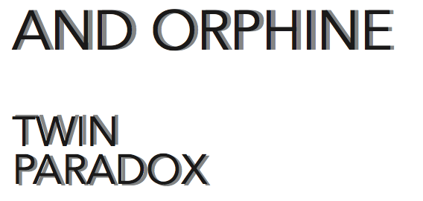

„In physics, the twin paradox is a thought experiment in special relativity involving identical twins, one of whom makes a journey into space in a high-speed rocket and returns home to find that the twin who remained on Earth has aged more.“
„Twin Paradox“ as an album title describes this physical and emotional ambivalence. An alter ego or a twin existing only in our subconscience sometimes takes control in one’s life. The stories told here are about emotions we can’t change or handle and decisions we should make but simply are incapable of. Joy, grief and anger all come from one source which is ourself, sometimes divided.
Twin Paradox streches a line from Soul, Roots Rock and Folk straight to Electronic Music. The album provides songs spun from feelings and experiences about this state of disunity hung out on that line.

pics: Ursula Röck

