Kanaku Y El Tigre
Quema Quema Quema
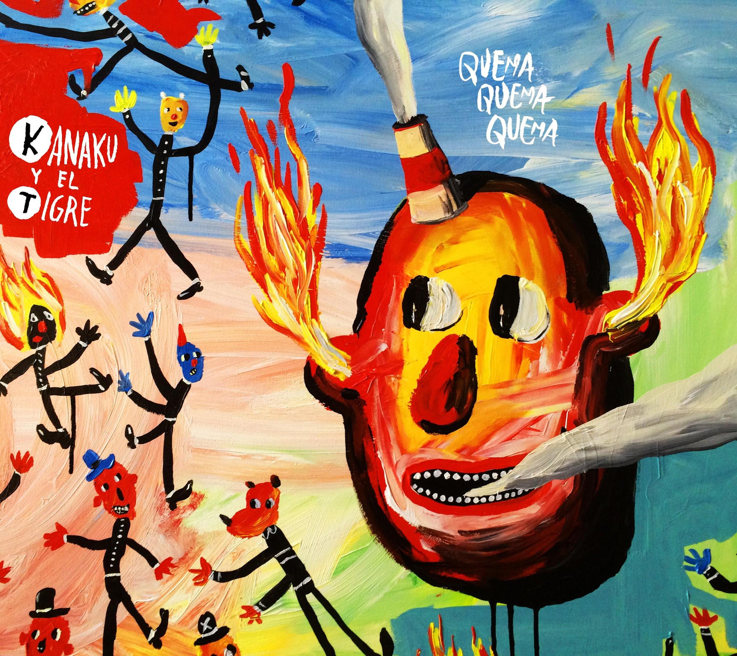
Format: CD, LP & Digital Download
UK Release Date: 16th June 2015
Label: Strut / Tiger’s Milk
Cat: STRUT130

Peruvian 'wandering folk' beatniks Kanaku y El Tigre, release their sophomore (and first international) album, ‘Quema Quema Quema’, via the acclaimed Strut imprint in conjunction with Tiger’s Milk Records. This anthemic, hook laden slice of electronic tinged indie-folk, direct from Lima, could very well become a soundtrack to the summer.

‘Quema Quema Quema’ (meaning ‘Burn Burn Burn’ in Spanish and lifted from Kerouac’s ‘On the Road’) is the product of two years honing the Kanaku sound at the band’s Lima studio HQ and the result is a record which is feverish in intensity and which screams with joy and cries for help in the same breath.

Back in 2010, their debut album ‘Caracoles’ brought Kanaku’s creative duo Nico Saba and Bruno Bellatin considerable success and acclaim in Peru with a set of quirky songs inspired by American folk. Including a hit single with the title track, and second single used in a couple of film soundtracks, the album was considered to be one of the country’s albums of the year. Five years on, and creatively the band have transformed themselves. ‘Quema Quema Quema’ is testament to their newfound approach with its euphoric, unapologetically feel-good hooks littered with electronic jitters, ghostly delays, serene Hawaiian slide guitars and a chorus of other-wordly vocal harmonies.

Featuring ten songs including two sung in English, ‘Quema Quema Quema’ is guided by the tortured, impassioned vocals of lead singer Nico Saba and it is the relationship between Nico and Bruno that forms the most vital dimension in the band’s sound. “With the new album, we have focused consistently on the melody and the song despite a multi-instrumental approach,” explains Bruno. “We have always shared this process of dreaming up ideas - we both bring light and darkness into the room and use each other as creative mirrors.”

Their strong musical partnership stems from the ‘90s, when, in their early teens, they were kicking the dust together in a punk band in downtown Lima. Now in their late twenties and both now bilingual having lived for periods in the UK and the States, their sound owes much to western music forms. Despite being very different characters with near opposite tastes in music, as life-long friends, they see the fruits of their creative partnership as a mutual appreciation living life charged, intense and always ready to ‘Burn, Burn, Burn’. Lead single, ‘Si Te Mueres Manana’, with its freewheeling long-boarding video shot on Lima’s coastal roads perfectly encapsulates the Kanaku philosophy. Translated, the lyrics state, “if you die tomorrow, make sure you you've done everything you ever wanted”.

To complement the fluid production and sonic oddities peppering the tracks within ‘Quema Quema Quema’, Argentinian graphic artist and cartoonist Ricardo Liniers has brought childlike surrealism to the album artwork, complete with simplistic stickmen and an exaggerated floating head oozing flames and smoke from every orifice.

The momentum for the band is already building in Europe with Omega watches using their music for an extended film featuring a Cindy Crawford voiceover. 2015 is set to be a major breakthrough year for Kanaku y El Tigre.

1. QUEMA QUEMA QUEMA
2. NUNCA ME PERDI
3. PULPOS feat. Leonor Watling
4. QUIEN SE QUEDA QUIEN SE VA
5. SI TE MUERES MAÑANA
6. BUBUCELAS
7. 10 AÑOS
8. HACERTE VENIR feat. Pamela Rodriguez
9. BURN BURN BURN feat. Sergio Saba
10. FIN

Contact:
Press: Dave McGuire | dave@ballantynecommunications.com | 07792867172
Online: Duncan Ballantyne | duncan@ballantynecommunications.com | 07582242802
Radio: Joss Yerbury | jossyerbury@googlemail.com | 07841 873 981 |

