- If you’re looking for the ‘next big thing’ in metal acts, look no further than Tuff Enuff.
- The Polish band have released in October 2014 their new album, "Sugar, Death and 222 Imperial Bitches" and is ready to conquer the whole world of metal music.
- Tuff Enuff mixes groove-laden hardcore/metal with punk and groove metal influences to create awesome, energetic and unique music, which band members and their fans call ‘Power Groove’.
- The band was formed in 1992 and released their critically-acclaimed debut album, entitled ‘Cyborgs Don’t Sleep’ in 1996. The band started playing sell out shows and their new album has received positive reviews across the Polish music media. Their second album, entitled ‘Diablos Tequilos’ was released in 1997. On this album, the band continued with their unique, recognizable style, spicing it up with some Latino-American elements. Both albums gained the band many enthusiastic reviews and loyal, committed fan-base.
- To promote both albums, the band played numerous concerts and tours, together with Testament, Fear Factory, Acid Drinkers, Vader, Illusion, Kazik Na Żywo, Flapjack, Blenders, D.R.I., Paradise Lost, among others. They took part in all the biggest festivals in Poland, including Metal Hammer Festival, Odjazdy, Przystanek Woodstock, Juwenalia, Ursynalia. The band members don’t take themselves too seriously, therefore their full of energy and humor gigs are unforgettable and the fans always come back for more!
- Year 2011 saw the band’s comeback in the original line-up. Both albums had been re-released, gaining the band a new, substantial fan-base and more enthusiastic reviews. Tuff Enuff played a tour in the biggest venues in Poland, and gigged with Pro-Pain, Slayer and Limp Bizkit.
- Tuff Enuff has been described as ‘one of the best metal bands on the Polish metal scene and the legend in heavy music.
- To promote new album, in November band went on tour around Poland.
- Now is time to go Worldwide.

- Are your ear drums ‘tuff enuff’ to tackle the next biggest metal music sensation from Poland?

- 10-10-14 is the date of the release of the new album, TUFF Enuff entitled "Sugar, Death and 222 Imperial Bitches".
- Ten tracks fused to thirty-five minutes of high-octane blend, where the metal mixed with punk rock, hardcore with pop and country music, and each song is sung in another language ...
- "It's loud, raw, uncompromising rock album. The songs were created in "correspondence system." "... working at a distance, exchanging millions of e-mails and files, and attempts were doing on Skype, making the production process we extended a little.”
- The album was recorded in as many as four different studios.
- In Norway - Norge Grorud, Poland - NEST, Britain - Bruce Avenue and Ireland - Park Road Studios, and for mixing and mastering a whole is responsible sound engineer Jacek Miłaszewski.

- http://tuffenuff.info
- https://www.facebook.com/TuffEnuffBand
- https://www.youtube.com/playlist?list=PLbAubgbKiIR3OUYHe9qs5yzS24URiPw60
- http://www.youtube.com/user/ziutt

- 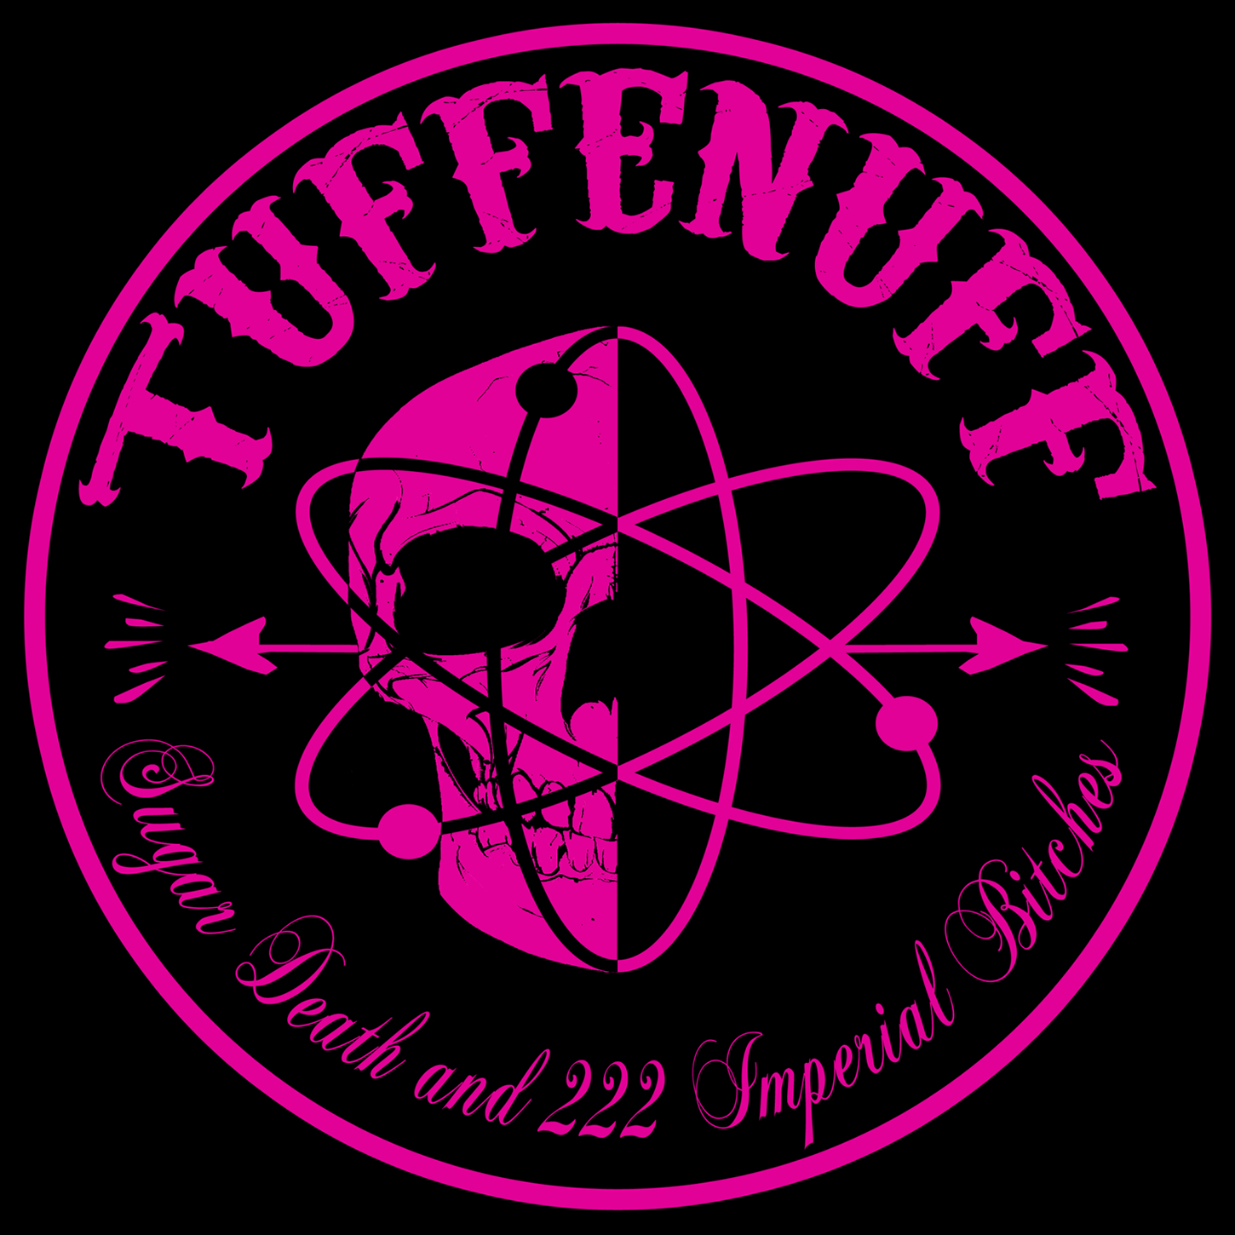
- 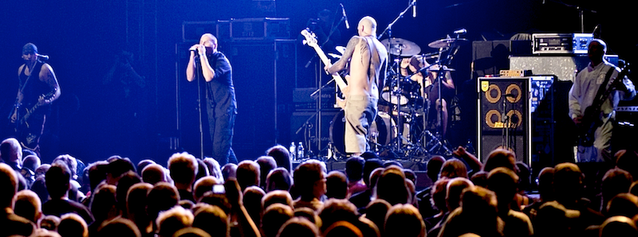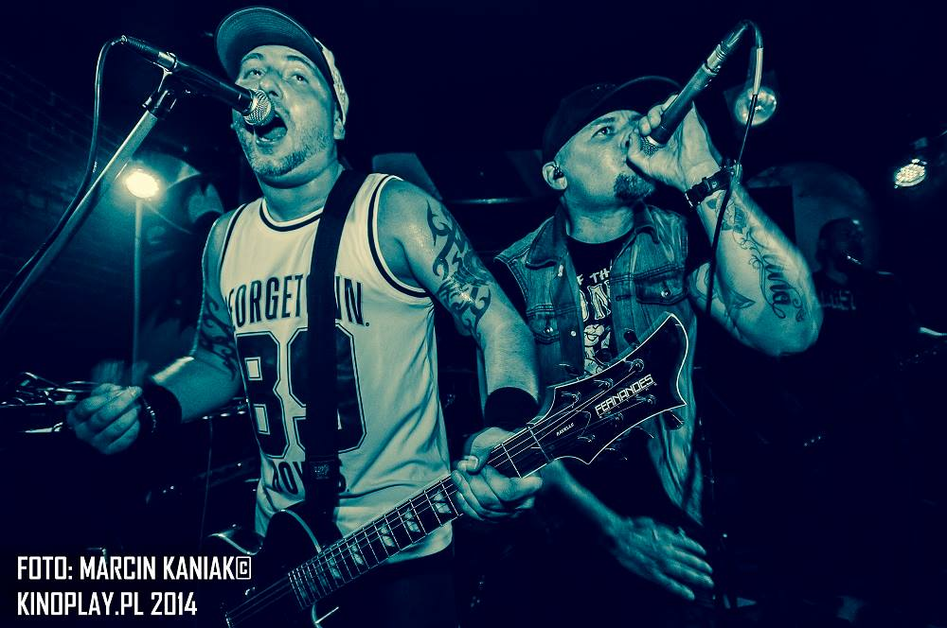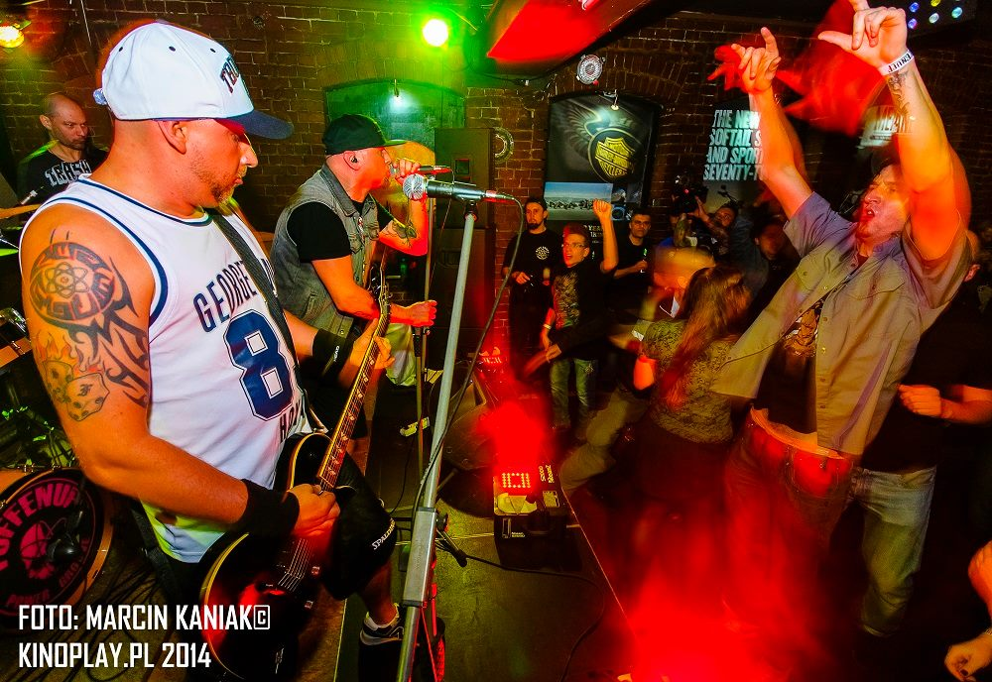

- 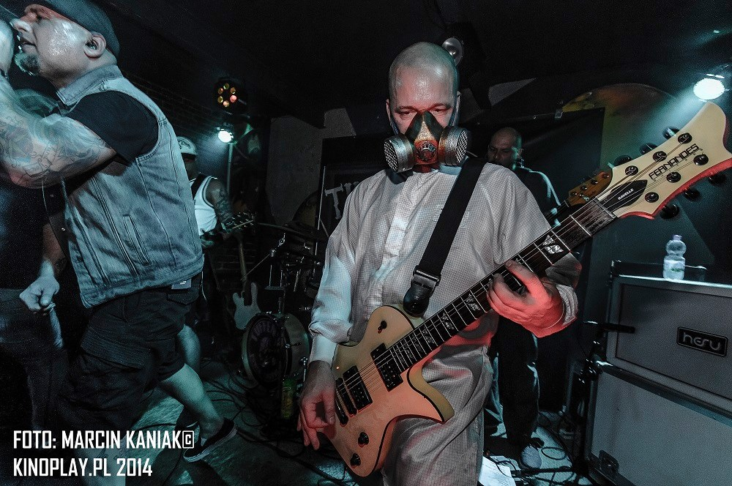
- 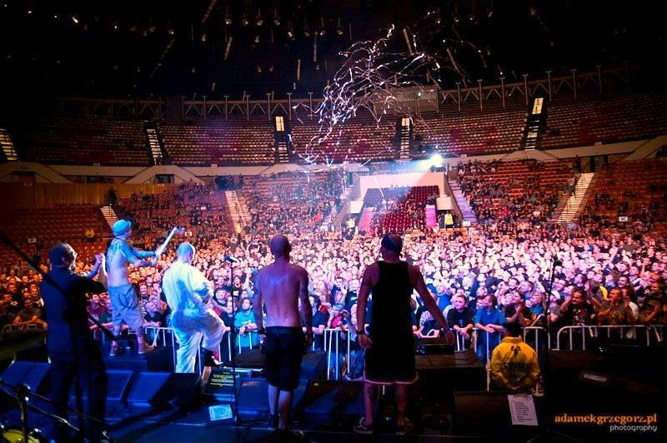

TUFF ENUFF :
Rafał TARACHA Taracha
Tomasz SIVY Biskup
Tomasz ZIUTA Zdebik
Adrian QLOS Kulik
Lukasz ROMAN Romanowski

Kontakt:
Tomasz Zdebik
ziutt@wp.pl
mob.+447882045037
https://www.facebook.com/TuffEnuffBand

