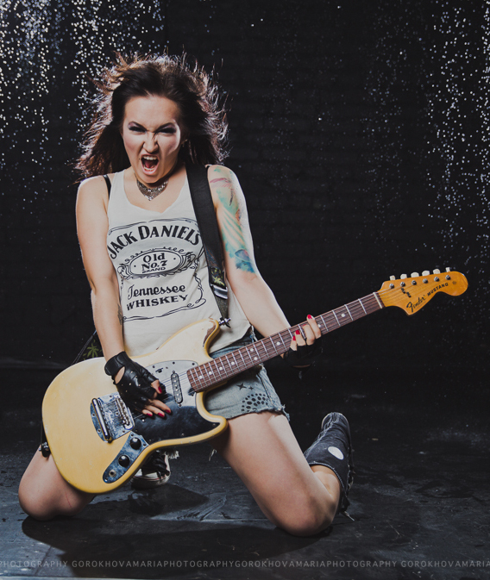
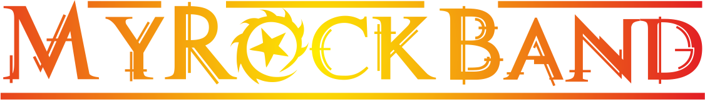
"Here we are, born to be Kings and the Princess of the Universe!"
-My name is Nika Comet and this is MyRockBand!
MyRockBand is a young but experienced band from Moscow, Russia.
It has quite a classical line-up (drums-bass-2 guitars-vocals), with a true space object on vocals - the band's front-woman Nika Comet is a pure bundle of energy!
MyRockBand modestly defines their genre as stadium-rock clearly hinting what they are aimed at. But in general it's just a mixture of music styles they listen to and admire: The Queen, Nirvana, Foo Fighters, Pink, Muse, and some other great idols.
Within 3 years that MyRockBand exists they released 1 full-length album mostly and 3 singles, now available on iTunes, GooglePlay and Amazon.
Despite being quite young these guys are on rock-stage since 2005 when they started their first school band.
The band has performed regularly since then (until 2012 under the name
"The SUN") in Moscow clubs with capacity from 30 people to 1000 ("YotaSpace", "IKRA-club", "Tochka", "Tabula Rasa", etc.), at big open-airs and festivals for the audience from 500 to 2000 people as well as at corporate and private events for famous brands such as L'Oreal, Givenchy, Louis Vuitton, etc.They performed at almost all biggest Russian rock-festivals such as an international festival "VOZDUH" (for which MyRockBand recorded an anthem), "Dobrofest", "MotoMaloyaroslavets", etc.
The band had also taken part in a TV-show "STS lightens a superstar" (similar to "American Idol" but for bands) and went to the final after 2-months on the project. Though have been born in cold-wintered Russia MyRockBand's musicians have sooo much fire inside they wanna share it with the whole world. The band used to write songs in Russian but is now focused on English as Nika speaks English and French fluently.
In the end of 2014 MyRockBand launched their own d.i.y. reality-show on their about musicians going for their dream called "MyRockBand Show". Due to the lack of staff and technical equipment the show was closed after 6 episodes but it attracted some new audience to the band and is still available on MyRockBand's official YouTube Channel.
This is MyRockBand, this is your rockband. It is pure and honest energy, drive and euphoria. This is the energy of life and youth, stay rock!

MyRockBand's main internet-resource: http://vk.com/myrockband_ru
MyRockBand on Facebook: http://facebook.com/myrockband.ru
MyRockBand on SoundCloud: http://soundcloud.com/myrockband
MyRockBand Official YouTube Channel: http://youtube.com/myrockband2012

