NECO
Digital Hustle
RELEASE DATE: 30th April 2015
CAT NO: EXD016
EXIDE CODE RECORDINGS

1. Neco – Drops
2. Neco – Hertz
3. Neco – How Long
4. Neco – Ying Yang

Copenhagen’s Neco may only be 22 years of age, but the producer, currently based in Vienna, already has his own ‘Neco Sound’, at the crux of future bass, trap and urban. Blazing a trail in developing new musical areas, he now brings his beats to Exide Code Recordings, with his new Digital Hustle EP.

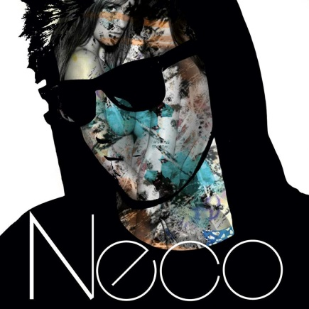
The EP’s title refers to Neco’s travels making his way to the top of the music world, and off the back of support from Milo Mills, Snakehips, 8ers and more. It’s clear that the young musician is really making waves. Four amazing tracks await you on Digital Hustle.

Drops is one crazy piece of music, from its sped-up, choppy intro into the masterful drop, Neco is on fire throughout this one. Presenting a whole range of styles and emotions, this one has something to move every crowd. Driving synths, light drums and well-placed samples complete the picture of Drops. Hertz takes things far into the next level, with an epic opening, which slowly and deliberately builds to the first drop, where head-nodding beats take over. Neco knows how and when to throw on the style, and all of his tracks have a block-rocking basis to them. Hertz is no different, with booming bass underpinning the beats and flavour he puts in.

How long, is the question on the next track, as the producer takes you further into his mind and imagination. Ticking electronics surround the main sample, before flashing beats enter the fray. Smooth, effortless transitions come in next, with synths and keys taking you ever higher. After all this, the finely engineered drums lead out to a fine finish.
And Ying Yang drops in some live-sounding elements, with layers of drums and percussion moulding their way around off-breaks and lines of samples. Twisting, turning with every phrase, Ying Yang perfectly sums up Neco’s approach and delivery.

Take a ride, take a trip, into the world of the Digital Hustle EP.

