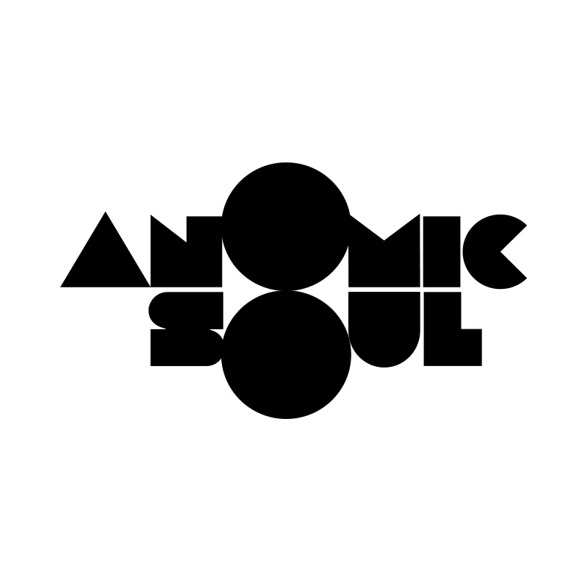

Catering Rider:

Pretty straight forward

- Water
- Access to good food

Thanks! - Anomic Soul

