Rangoon Sons

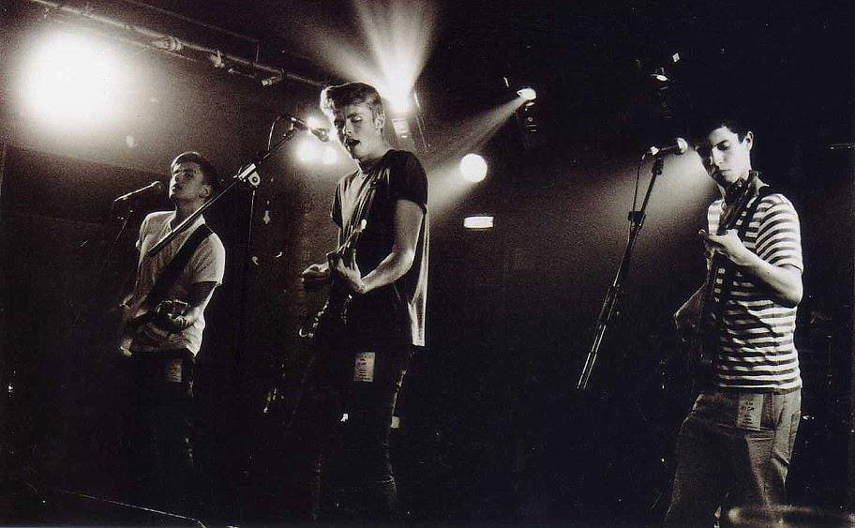

**Biography**

Based in Liverpool, Rangoon Sons are an unsigned band consisting of brothers Andres and Daniel Hernandez, Felipe and Ricky Davis-Guzman and their cousin Mike Davis; creating melodic narratives reflecting first person experiences. Their use of memorable vocal melodies, leading synth/guitar lines and alternative rock drumming help to create their wall of sound.

Formed in 2014, Rangoon Sons take inspiration from the likes of Alt-J, Arcade Fire and Foals. Their sound can range from a thick anthemic texture, to completely stripped vocal harmonies.

They have been shaping their live performance over the last 4 years through their experience in other bands and exploration of musical styles, using this level of experience to create what can only be described as a dominant, show-stealing live performance.

Their debut EP as Rangoon Sons was recorded in Whitewood Studios, Liverpool, in October 2014 with a view to release it in Spring 2015, along with their first music video. Their track ‘Waterline’ has received radio play on BBC Introducing Merseyside, with other tracks from the EP receiving radio time on smaller scale stations.

The band is currently refining their material which will soon form to create their debut album.

.

**Contact**

e-mail

[rangoonsons@gmail.com](mailto:rangoonsons@gmail.com)

Facebook

<https://www.facebook.com/rangoonsonsofficial>

Twitter

<https://www.twitter.com/rangoonsons>

Instagram

<https://instagram.com/rangoonsons>

Soundcloud

<https://soundcloud.com/rangoonsons>

Contact Numbers

07930612931/ 07411720545/ 01704830891

**Live Highlights**

ONES TO WATCH

02 Academy, Liverpool- November 2014

UPSURGE

02 Academy, Liverpool- September 2014

FARM FESTIVAL

Wirral, UK- May 2014

JUST SO FESTIVAL

Cheshire, UK- August 2013

LIVERPOOL SOUNDCITY

Liverpool- May 2013

WINNERS OF LIVERPOOL ROCK’S BATTLE OF THE BANDS

Liverpool, The Picket/The Baltic Social/Parr Street/ 02 Academy-

January to April 2013, 48 bands in total. Won under previous band name ‘Broken English’.