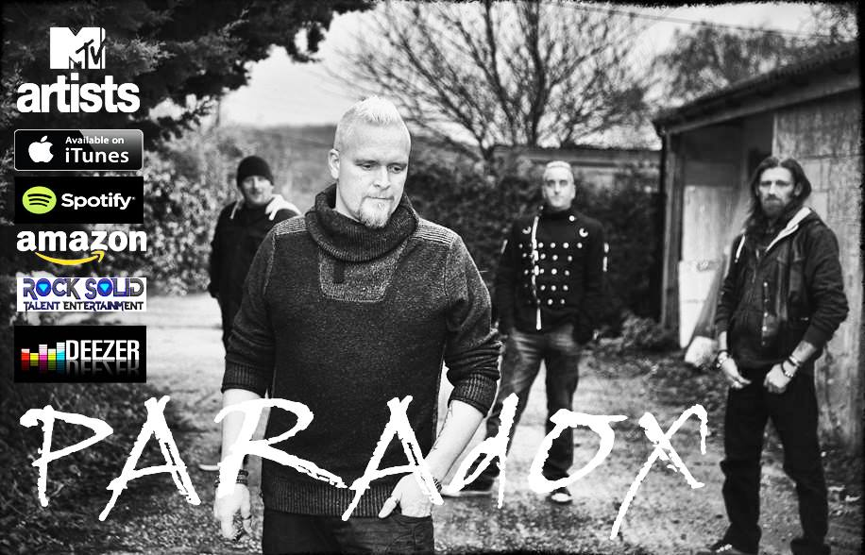

Contact Bex – 07843 925206
Email paradoxukmail@gmail.com
www.theparadoxuk.com

Vocals – Iain
Bass – Bex
Guitar Phil
Drums - Woody

Biography
PaRaDoX
Is a high energy Rock/Aggressive Indie Band based out of Kent, England.
This UK Band includes:
Iain Ogburn - Vocals
Phil Brown - Guitar
Bex (Richard Beckwith) - Bass
Woody - Drums
PaRaDoX has the reputation for dynamic and energetic shows.
They are a first class live act!
Their music is passionate, powerful and high energy.
They currently tour throughout Europe and have created a buzz. This talented act is fast becoming a "must see" band!
Their influences include many high energy rock bands:
The Who, Nirvana, The Sex Pistols, The Jam, Public Image Ltd.
& Green Day, to name a few.
Signed
To a Swiss record company and released their debut album
Silently Screaming, 2005.
They reformed in 2013, after a 6 year break.
High Points
PaRaDoX was signed to a Swiss record company and released their debut album 'Silently Screaming' in 2005. Paradox reformed after a 6 year break in 2013.
PaRaDoX will be releasing their new album late 2014. Currently signed to digital distribution company - AWAL, sharing the roster such acts as
The Cranberries, Travis and The Arctic Monkeys.
PaRaDoX has gained local media attention. This includes many local radio stations across Kent; as well as enjoying radio coverage in Europe and the USA.
Music Reviews
"At a lot of shows I attend you often find the crowd don’t respond this well to the original material being played but with tunes like this PaRaDoX really do whip the crowd in to a frenzy."
Dan Theman @ GIGglepics
http://gigglepics.co.uk/paradox-single-launch-the-harp-restrung-review-short-interview/
"Paradox is, although not duly credited enough, one of the greatest purely independent rock bands to come out of the UK in the past 10 years."
Gelgia @ Indie Artists
"One of the most engaging bands to watch performance wise and their set was so strong that people were unaware that the majority of the set were originals, such is the quality of their own material. I really, really want you guys to go and see for yourselves, you’ll be blown away I promise you." Sarah Quinn @ GIGglepics
http://www.bbc.co.uk/music/introducing/artists/profile/show

