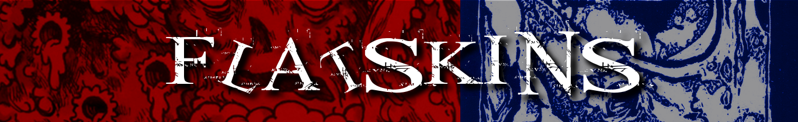
Formed on the 8th March 2014 in Sheffield, FLATSKINS have created and sculpted an eccentric sound and after a year of rehearsals and writing, they have stormed the local scene. This band is undoubtedly an amazing live show who, although only being a three-piece, like to use the full stage and excite the crowds.
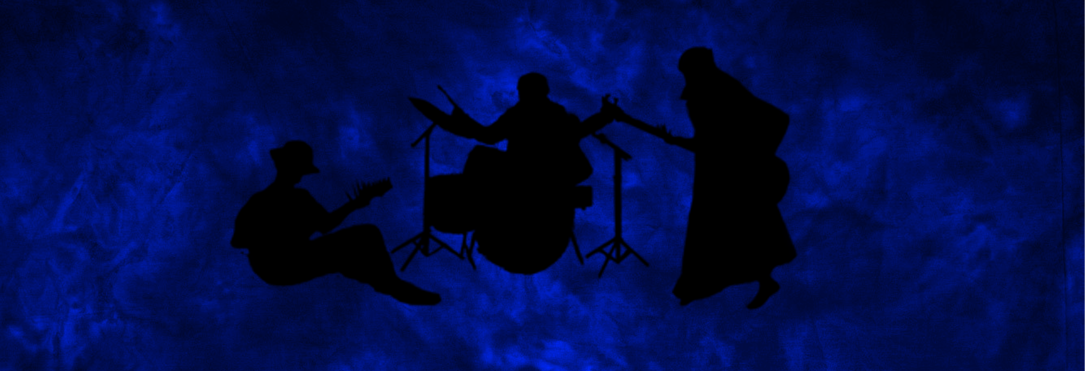
FLATSKINS not only love the music they create but they realize that being a band means being entertainers and therefore making sure the audience get's their money's worth. Putting on an energy-filled live show is extremely important to the three-piece.
In the future FLATSKINS would love to perform at an abundance of different festivals, events, venues, cities, countries and even planets if possible! so if this ear crumbling trio sounds like your cup of tea please be in touch!

Flatskinsband@gmail.com
Flatskins@outlook.com
www.flatskins.co.uk

