**The Simon’s** 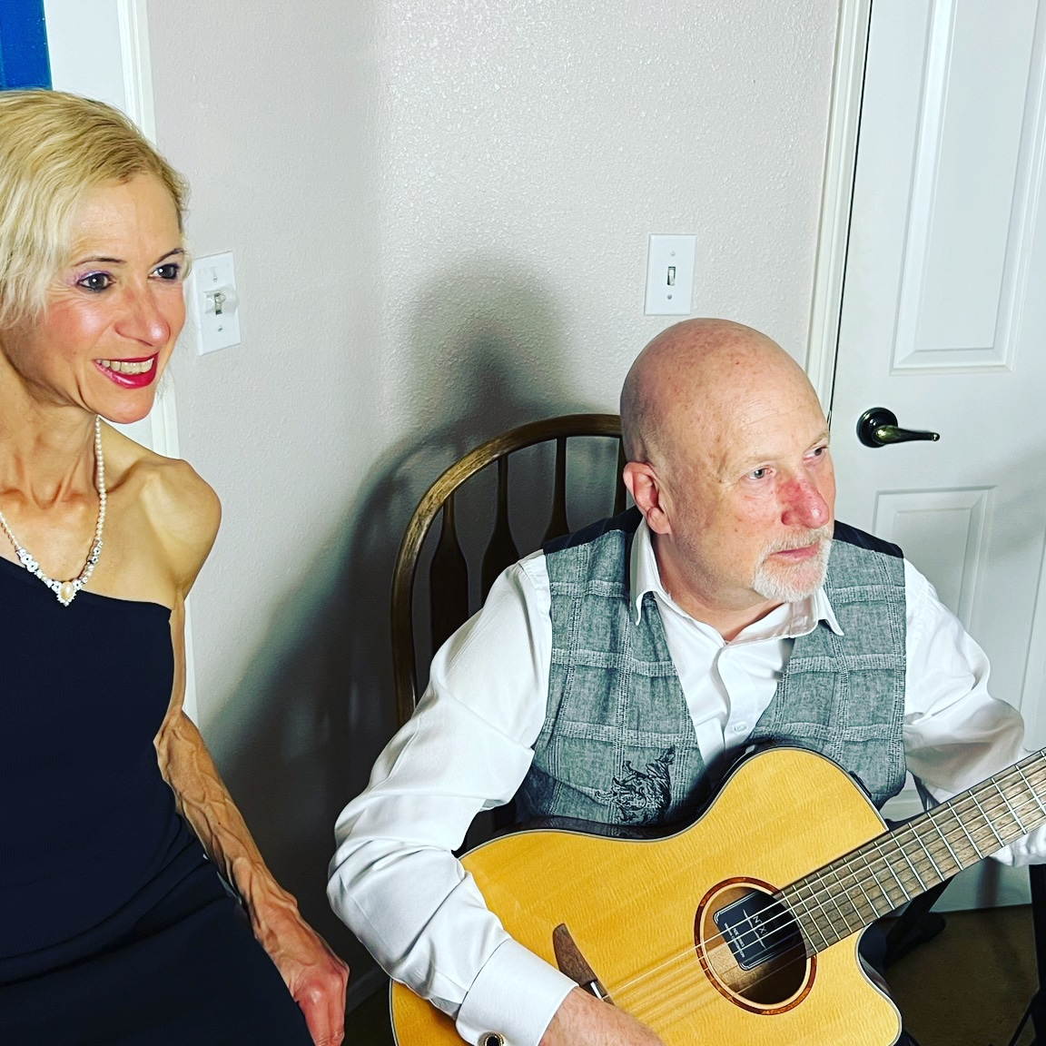

**Overview**

The Simon's duo (Adriana Simon, vocals, Robert Simon, guitar) have been performing for over 15 years in a variety of especial events, weddings, corporate functions, private parties, and live shows. Their music covers a wide range of repertoire including popular cover songs up to present time, in various styles such as pop, rock, ballads, and Latin music. Whatever the occasion might be their music will certainly make your event a memorable one.

**About**

Adriana Simon was born in Buenos Aires, Argentina, and moved to the States at the age of 26. She graduated with a Bachelor's Degree in Music from California State University Northridge where she met her husband Robert. Since childhood Adriana performed in numerous school and church choirs; she has many years of vocal training from her country and in the US. She joined her husband playing guitar, keyboards, and singing at different venues like Downtown Disney, and touring throughout United States and South America with great success.  
Robert Simon, born and raised in California, began to play the guitar at 13 years old. He graduated with a Master’s Degree in Classical Guitar from CSUN; he was always highly respected in College for his impressive technical abilities on the guitar, flawlessness, and mind blowing speed. As a duo, Adriana and Robert have released 2 albums, "Guitarra and Canto Tropical", and "The complete collection" which includes Robert's own flamenco guitar repertoire as a soloist, and Adriana's Spanish vocals in Latin styles.

**Contact, promotional video, and music link:**

<https://www.gigsalad.com/the_simons_fountain_valley>