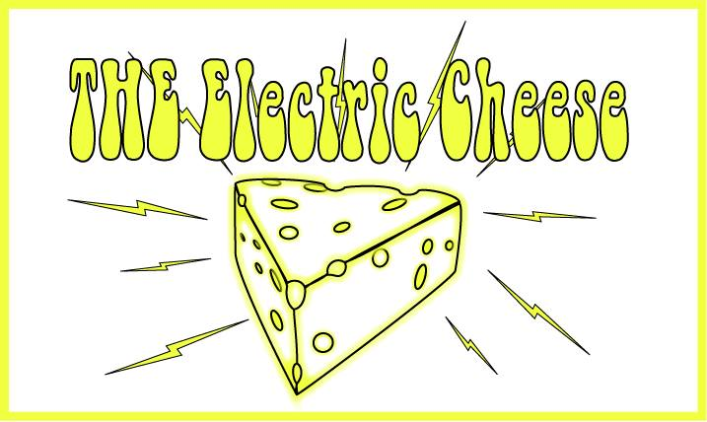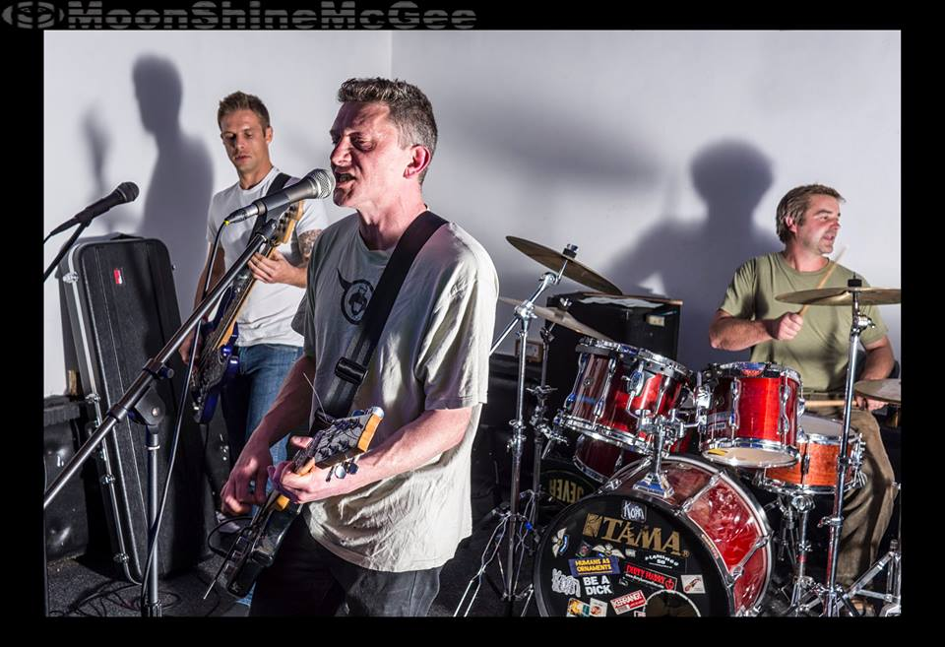

THE Electric Cheese are a psych-infused power-pop trio hailing from the sunny climes of Lancashire.

Formed during the spring of 2014, their shared love of all things curd-like helped Jason Gorgonzola (vox/guitar/witty lyricisms), Tommy Brie (bass/b. vox/tight t-shirts), and Matt Crumbly Lancashire (drums/funk/van owner) develop a varied set of songs that range from the electro-wah swirls of Leopold’s Apple to the galloping rhythms of Camels, via the achingly beautiful tale of dredge teams in Nome, Alaska, in Gold Divers: Under the Ice.

Having already garnered airplay on Salford City Radio, Tircoed 106.5, Australia’s Valley FM 89.5, and California’s KBYD Radio - and with a number of rapturously received gigs under their collective belt including performances at the Salford City Music Festival and Chorley LIVE! - THE Electric Cheese will be releasing the Lactose Intolerant EP via Manchester’s German Shepherd Records in March 2015.

The band is looking to supplement its busy calendar by filling the spring and summer months with nationwide festival slots, TV appearances, radio sessions, wedding receptions, birthday parties, and support slots with international touring artists. Local gigs in the Lancashire, Merseyside, and Greater Manchester region are also willingly accepted.

Email: info@theelectriccheese.co.uk
Soundcloud: www.soundcloud.com/the-electric-cheese
Facebook: www.facebook.com/pages/THE-Electric-Cheese/265217613683122
YouTube: www.youtube.com/channel/UCcTeyvcU8dqYJFEYK0rERaA
German Shepherd Records: www.germanshepherdrecords.com

