VILLIERS

Their New AA Side Single
‘You’re Not Alone’
‘Nowhere Left to Run’

Released: 15th September 2014
Format: Digital Download

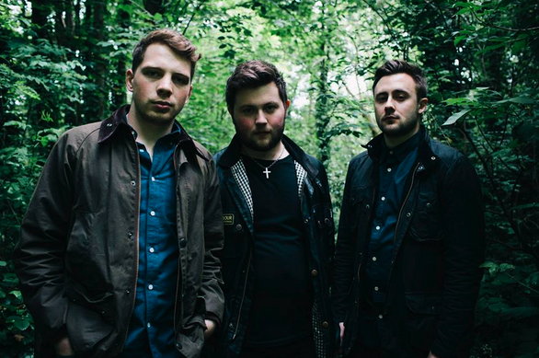

Following the success of Villiers’ last single ‘The Dancer’ released in June 2014, which saw the band featured on Janice Long’s BBC Radio 2 show and earned them international airplay and coverage, the trio are back with a double AA side ‘You’re Not Alone’ and ‘Nowhere Left to Run’.

Hailing from Lancashire, Villiers are an Alternative/ New Wave outfit who cite the iconic sounds of Depeche Mode and Echo and the Bunnymen as major musical influences. Lyrical inspiration comes from dystopian writers such as J.G Ballard and George Orwell. Since their formation in 2011 the band have released three studio EPs (Light the Fuse, Into the Haze and VLRS) earning them praise and recognition from radio DJs, bloggers and music magazines across the world.
Last summer saw Villiers break onto the UK festival scene with a slot at BeatHerder alongside Clean Bandit, TOY, Temples, Chic ft Nile Rodgers and Groove Armada. This year they played their first headline show at Manchester’s Night and Day and have been invited to play more UK festivals. Villiers are sealing their reputation as one of the north-west’s most exciting and innovative new bands.

Praise for ‘The Dancer’

“This song really, really gets me.” Janice Long, BBC Radio 2

“The Dancer is the summation of the journey so far and is a smart piece of song-writing and delivery as Villiers rightfully stamp a claim for the rationale of their travels so far.” Emerging Indie Bands

“A dark coldwave synth track that recalls the hard, sleazier edges of Soft Cell.” Fecking Deadly

“The Dancer” is a deep, dark, brooding jam that will have you prowling the dancefloor.” DNNM

“Haunting and Mesmerising…” Rock Britain

“Spellbindingly dark electro pop” Fame Magazine

Social Links

https://www.facebook.com/VILLIERSBAND
https://twitter.com/VILLIERS_BAND
https://soundcloud.com/VILLIERSBAND

Gigs

For radio interviews and live sessions please contact:
Andrea Lynch - andrea@bluesoapmusic.com 0161 947 0012 or 07557 749826
Ben Earnshaw – b.earnshaw@live.co.uk 07443508617

