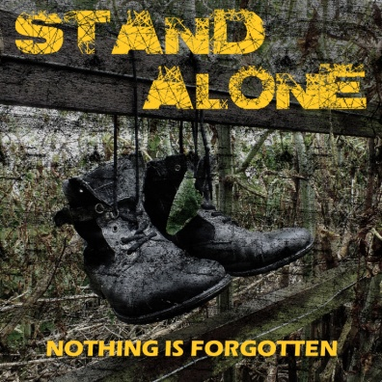
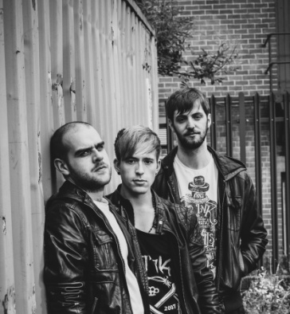
Stand Alone

EP Release
‘Nothing is forgotten’
Release Date: 12/12/14

Stand Alone’s Melodic, Heavy Rock sound can be heard above the Indie ‘scene’ that is currently droning on through their hometown; Bradford. With the release of their Debut EP ‘Nothing is Forgotten’ on the 12th December 2014, the Indie sound will soon be in their rear view mirror. Stand Alone is Gavin Stevenson on Guitar & Lead Vocals, Tom Durrans on Drum & Vocals and Luke Harrison on Bass & Vocals.

The name ‘Nothing is Forgotten’ comes from within their debut single ‘Easier Said Than Done’ (Track 3) meaning that everything you do, be it good or bad, can come back to haunt or praise you at any moment, which sums up many of the songs on the EP. While some of the songs deal with negative issues, the overall outcome is very uplifting which is also reflected heavily in the instrumentation and energy of each song. The opening track ‘False Beginnings’ for example starts off with someone who’s world has come crashing down around them, and by the time the chorus and second verse comes round, you as the listener, feel strangely optimistic.

The songs came together exceptionally quickly with each member putting their own influence together to create their unique sound. Take driving guitars, a tight low end and catchy hooks; add a few vocal harmonies and the odd riff that makes you want to punch the person closest to you (in a good way) and you have Stand Alone.

The EP will is available at most online stores including iTunes, Amazon, Google Play, Xbox Music and to stream on Spotify + many more. There is also a limited edition physical CD copies sold only at their gigs.
“Their tight line-up generates some fearsome power while remaining especially melodic. Vocal Harmonies were particularly impressive.” Simon Ashbury at BCB Radio

“‘Easier Said Than Done’. What did I think of this track? Nothing short of...it made me a fan the moment I heard it. It had individuality.”
Leeds Music Scene

Track listing:-
- False Beginnings
- This is Ours
- Easier Said Than Done
- Control
- Demons

https://www.facebook.com/standaloneuk
https://twitter.com/Stand_Alone_UK or @Stand_Alone_UK
http://www.youtube.com/user/standalonemusicuk
https://soundcloud.com/stand_alone_uk
https://standaloneuk.bandcamp.com/

Official music video for ‘Easier Said Than Done’:-
https://www.youtube.com/watch?v=IbV_Nv5nbIY&list=UUUk6GslLeq22ycnpR2Wcj-w

Other Contact Details:
standaloneuk@gmail.com
Gavin: 07810201690

