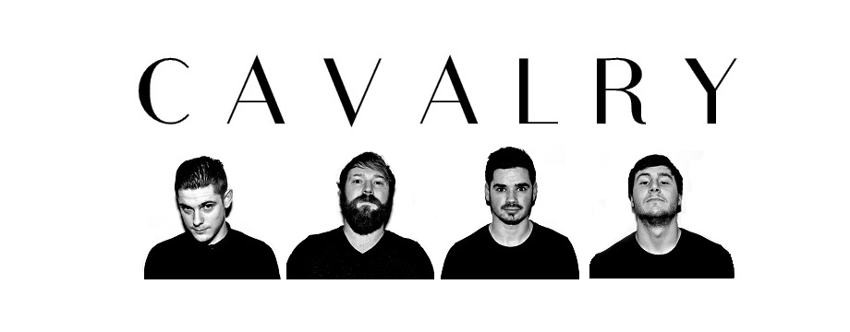‘Impeccably slick mould-cut pieces of pop-metal with expansive post-rock guitar parts.’

Noel Gardner – Buzz Magazine

‘Cloudbusting pop rock from new Cardiff band… their debut single harbours shades of Bombay Bicycle Club if they cared to carve out songs that played upon the quiet-loud dynamic quite as impressively as Cavalry’s sonic assault does.’

David Owens – Wales Online

Cardiff alt-rock quartet with strong beard game. A band with hooks to fill some big rooms. Currently writing new material, so eyes peeled.

Huw Baines - Stereboard

