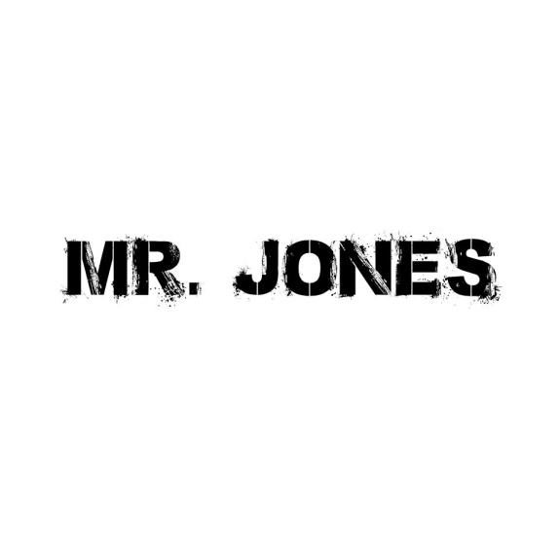
TECHNICAL RIDER (Stage Plan)
Mic
Mic
Mic
Mic
Bass-
Amp
Monitor
Monitor
Monitor
Monitor
Guitar
Amp
Keyboard
Lead
Mic

Mic
DRUMS

