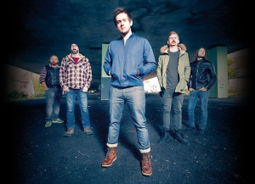

Talk In Code - New Single Produced By Geoff Swan (Ed Sheeran, Beady Eye)

‘Stand’ Released Monday 23rd March
Recorded and produced by Geoff Swan (Ed Sheeran, Haim, Beady Eye), ‘Stand’ is the final single from anthemic indie pioneers’ self – titled debut album TALK IN CODE. The track showcases an expansive, thumping sound whilst never losing the songs’ sentiment – a familiar tale of being stuck in a vicious circle!
Highlights for the band throughout 2014 included support slots with Catfish & The Bottlemen, Amber Run & EofE, alongside festival appearances at Alresford, Oakwell and City Showcase. TIC have had strong backing from regional BBC Introducing networks and perhaps the icing on the cake was the debut single (Make It Happen) being featured as Q Music’s Track Of The Day.
New single ‘Stand’ is released on DO IT! Records, Monday 23rd March 2015 –along with B-side ‘Brave The Elements’. See the video to ‘Stand’ here: http://youtu.be/kEbIWGc1vIA
Talk In Code play the following UK dates in 2015:
20th Feb Worthing Bar 42
21st Feb Andover The Rockhouse
10th Mar London Scala
26th Mar Swindon The Vic
04th Apr Newbury Corn Exhange
08th Apr London 1001

Online:
Website: http://www.talkincode.co.uk
Facebook: https://www.facebook.com/talkincode
For all press enquiries, features and guest list, please contact:
anthony@iaatouring.com - 0044 (0) 1273 305752

