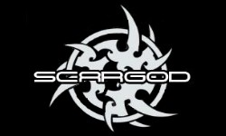
Born in the year 2013, as a Black Metal Project, the project turned very fast into a full Band with well-known Austrian scene Musicians from Bands like Shadows Grey, Edenbridge/Thirdmoon, Groteskh/Hellsaw, Serious Black and Demolition. Mastermind Martin “Maze” Moser had the idea of a Black Metal Band without confinement within genre limits. So the band was born out of hell´s most obscure blackness presetting without retrench itself. AND all comrades- in – arms ensueded. Those comrades – in – arms are:
Dr. Maze Pain (Shadows Grey), Malthus Unholytoxicomaniac (Hellsaw, Groteskh), Mike Hell ( Disastrous Murmur, Tongueless Cuntkiller, Sakrileg) and Feanor Omega (Svartsorg, Sakrileg, Nebenfront).

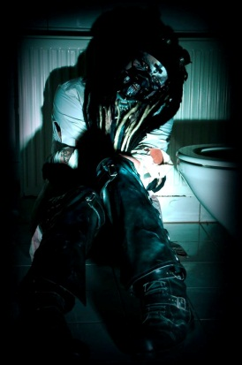
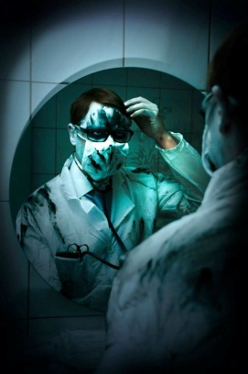
Denomination is program. It is time. A name, a band, to conjure with! Martin “Dr. Maze Pain” Moser has a SCARGOD Tattoo and now the Band and the Music will be tattooed in everybody´s mind, ears and necks! The influence of all musicians is radical and tangible. Because of that, the 2014 pummeled, sensational and thrilling CD, is an Album you never heard before!

Of course we search the right and perfect commercial partner for our journey and our second Album, which will be still unique and innovative.

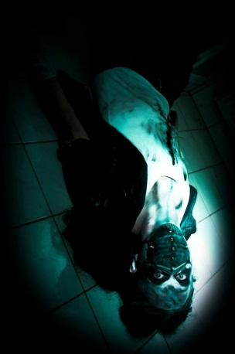
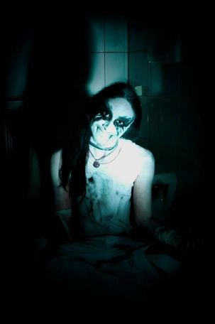
The recordings were done in the end of 2013 at the well-known german Dreamsound Studios in Munich. BUT: The producer of this SLUG were Dr. Maze Pain itself with helping hands of Mario Lochert and Jan Vacik. The Mix and the Mastering of the record was done by Jan Vacik (Serious Black) and Mario Lochert (Emergency Gate, Serious Black). The Pre-Production was done by Dr. Maze Pain.
AND WE ARE PROUD TO ANNOUNCE, THAT WE RECORDED THE ALBUM WITH A REAL LIVE ORCHESTER!!

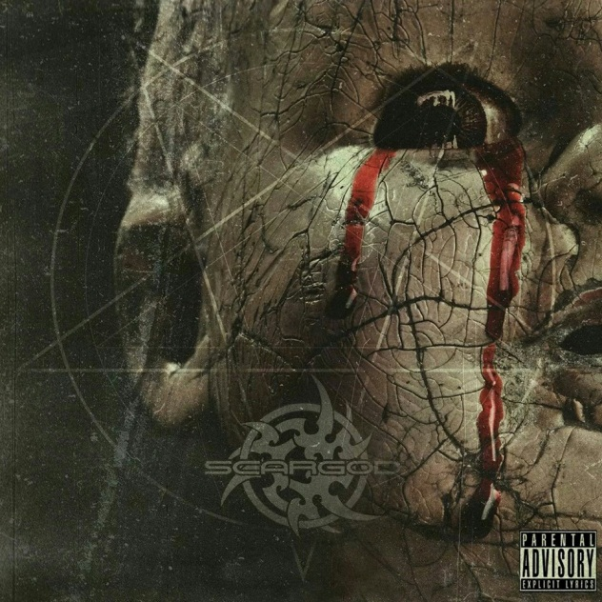
Helping Hands:
Dominik Sebastian (Edenbridge, Thirdmoon, Serious Black): All guitars and Basses;
Lisa de la Wag ( Adamon): female vocals

Christcrusher (Thy Nemesis, Kirchenbrand): clean male vocals
H.P (Demolition): Bass on “Nuns…”

Lukas Knoebl (Illuminata): Orchester Rearrangement for
“Ravished…”
AND FULL OF PROUD WE CAN PRESENT: The original and live played “Scar of God” Orchester!!!

After some change, the Band is:

Dr. Maze Pain: vocals, programming, songwriting, composing, arrangements, Orchester adaption and arrangemens…
Malthus Unholytoxicomaniac: Guitar;
Mike Hell: Bass
Feanor Omega: Drums

Now some words from Bandleader Dr. Maze Pain:

I am proud of what I have done. I think by myself, that I recorded and wrote an Album that is no 08/15 Metal Album. I think it is innovative and unique. So, when you listen to it, always think of that. I also have to say, that everything on that Album is quite the thing, what I wanted to do. Every note, every song, Really everything. So, have fun with the album – or keep your hands off.

Rock on
Dr. Maze Pain
SCARGOD
http://www.facebook.com/scargodband
http://www.reverbnation.com/scargod
http://www.scargod.net

