Dear ,

New EP ‘The Patron Saints of Lost Causes’ to be released on __________

2013 marks the 10 year anniversary of the marrying of the singer/songwritering of Morgan Tatchell-Evans with the rhythm sectioning of Kirsty Dolan (bass, singing) and Alan Kenworthy (drums). In order to avoid the potential rut such constancy could induce, the team have been changing things up a little:

Change number one – a new guitar player has joined the fold, in the shape of Wot Gorilla? main-man, Matthew Haigh (long-time Chico devotees will recognize him as a past member of the group, making him something of a prodigal son figure)
Change number two - Morgan has hung up his guitar and bought a keyboard

The result of these changes is the forthcoming EP, ‘The Patron Saints of Lost Causes’.

As with the band’s last release, 2011’s ‘The Seasons EP’, a fuller sound and broader palette are in evidence in comparison with earlier offerings. Righteous, shout-along choruses and unhinged guitars populate opener ‘The Golden Ones’, giving way to the hushed intensity and time signature changes of the title track. ‘Thinking About It’ briefly recalls trance producer ATB, before gradually expanding into massive, heart-on-sleeve indie rock. Closer ‘Turn This Ship’ sees Matthew’s spidery guitars wrapping around Morgan’s twinkling Rhodes before the measured build-up and insistent vocals of the outro bring things to a pounding conclusion.

Lyrically, the collection tells the story of a young, idealistic couple struggling to deal with the moral maze of paid employment. The narrative takes in a couple of meltdowns, a smattering of dry Yorkshire wit and a bewildering array of transport related metaphors. And everyone’s happy in the end.
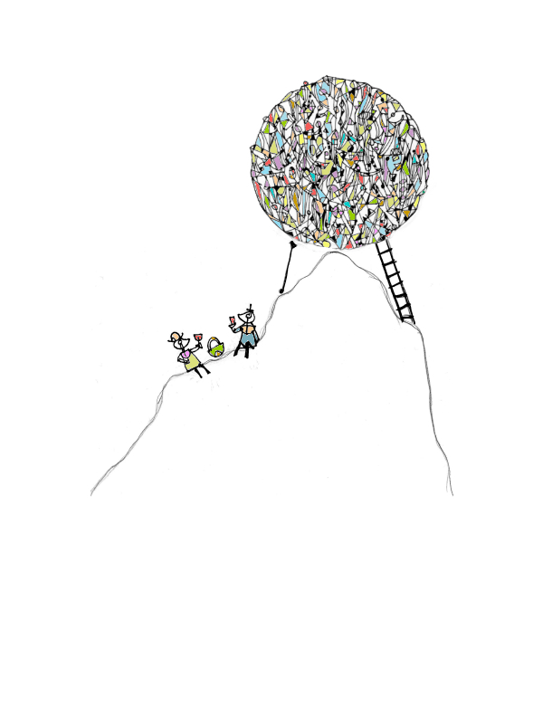
We hope you like the songs.

All the best,

Buen Chico
buenchicotheband@yahoo.co.uk
www.facebook.com/buenchicoband
www.philophobiamusic.co.uk
'Quintessentially English indie'
Q Magazine
“brilliantly spiky geek-pop firecrackers that jolt like Foals knifing Supergrass"
NME

'A band radiating with positive sounds, even when dealing with darker issues...a tight and awesome as fuck guitar pop band'
Rhubarb Bomb
'Buen Chico are a living embodiment of the idea that less is more, crafting a blissfully contented joypop.'
Bearded Magazine
“shit name, good songs”
Drowned in Sound

