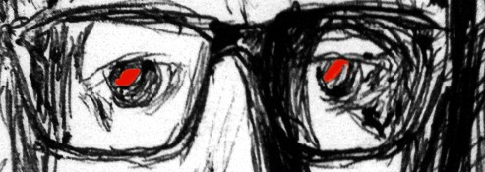

Mat Motte is a Singer / Songwriter / Performer from London. We challenge you to find anything else in this world quite like Mat. Energetic, feisty and a little bit bonkers, Mat really is the definitive ‘one off’ in a music world increasingly populated by copy-cat opportunists and serial re-hash- ers. Mat started out fronting Mower, a three-piece indie pop band, who was spotted by Blur’s, Graham Coxon. After releasing a couple of albums on Coxon’s, Transcopic Label, and tours with Scissor Sisters, British Sea Power and the Futureheads, Mower eventually called it a day. Mat’s intense new sound is the result of being locked away for a couple of years, in the Worcestershire marshes, with only his old funk and hip hop LP’s for company.

Mat is now wreaking havoc in venues across the land, and has finished recording his debut solo LP with Oli Dreamtrak. Tracks including Tunnel Vision, Acid Tongue and Crack Pot, along with a much-lauded cover of Talking Heads’ Psycho Killer, champion a musical force that tinkers with influences including Parliament Funkadelic, The Rapture, Captain Beefheart, A Tribe Called Quest, Gang of Four, The Chemical Brothers and much much more.

Accolades

NME Single of the Week accolades (Na, and Drinking for Britain) Radio 1 Singles of the week (Zane Lowe, Evening Session and Marc and Lard)

What other people say about Mat Motte:
“Music that douses itself in gasoline and plays with matches, always on the verge of some kinetically-satisfying explosion or self-destruction.” – NME “How Blur might have sounded had Coxon managed to wrest Damon Albarn’s hand from the creative tiller. Raucous and rowdy, this throbs with primal
intensity”… – Q

“Fortunately for the former frontman of indie-pop trio Mower, the upcoming “Summer Song” is sort of, kind of brilliantly bonkers..” – The
Independant

“It’s a glorious catchy bastard of a tune, and it is hollered reassuringly loudly. Oh Yes” - Louder Than War

“An infectious indie singalong for the summer. It has dug its way so deep into my headspace, like any proper anthem should” - Single of the
Day, God is in the TV

“What Motte has also done though is cleverly turned the pain of the subject matter into a very upbeat and enjoyable tune” – Glasswerk

Singles Summer Song and double a side High Maintenance / Lame are out now via Plethora Records

MAT MOTTE CONTACTS:
Hear Mat Motte: soundcloud.com/matmotte
Stalk Mat Motte: twitter.com/matmotte / facebook.com/matmotte
Ogle Mat Motte: youtube.com/MatMotteOfficial

Plethora Records: twitter.com/plethora_uk

