Graeme Wilson Quartet

Electronic Press Kit

1. The Band

2. Bio

3. Reviews

4. Contact Details

The band

Graeme Wilson tenor saxophone
Paul Edis piano
Andy Champion double bass
Adam Sinclair drums

The Quartet is all about heartfelt improvisation on idiosyncratic tunes that stay with you. The players infuse driving jazz and latin rhythms or ambient swing with their various enthusiasms including folk and rock ballads, free jazz and the dancefloor. Their original material explores unusual meters and structures as vehicles for angular and passionate solos, with narrative melodies resonant enough to evoke a strong sense of place and time. The four musicians enjoy a close communication from long track record of playing together in other bands; the Quartet aims to let four creative improvisers explore the possibilities and diversity of contemporary jazz.

“as good as it gets” – Bebop Spoken Here blog

Graeme Wilson Bio

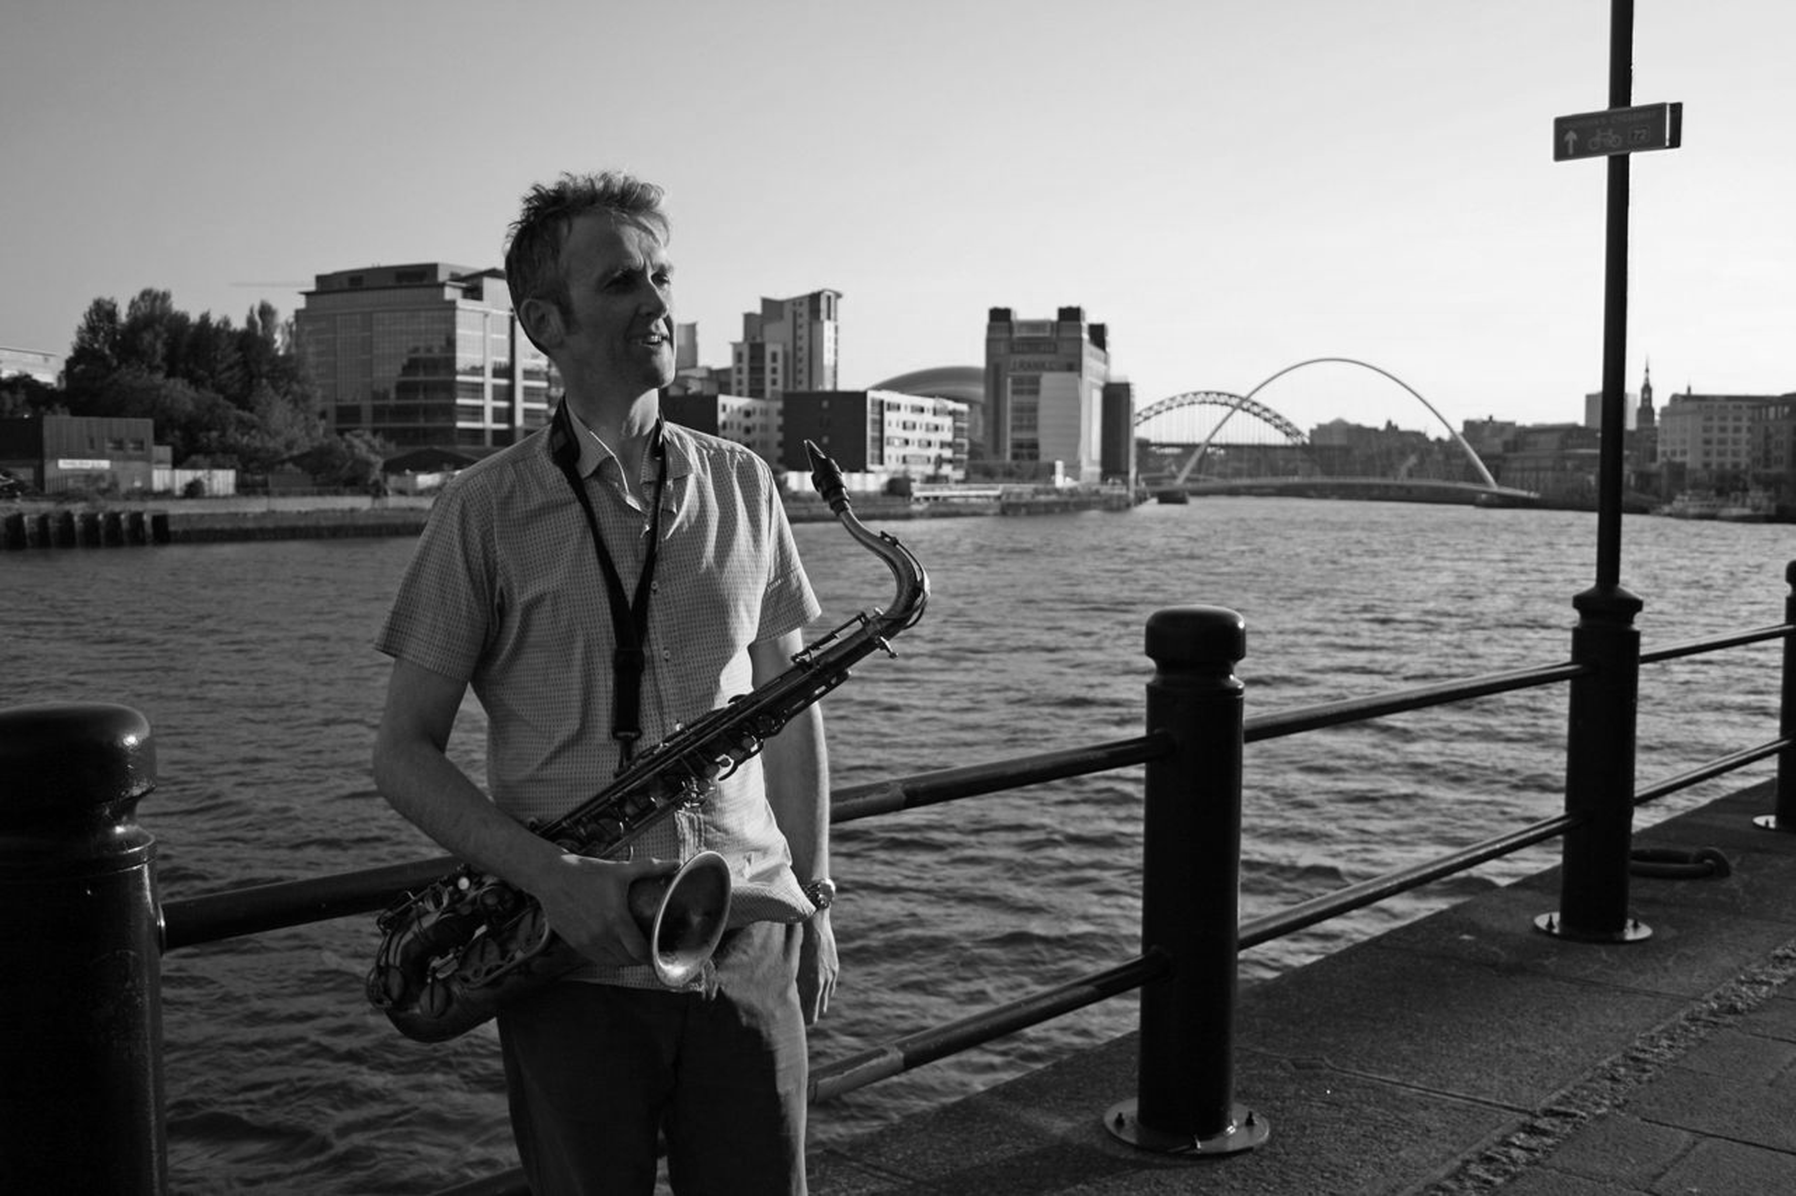

Graeme Wilson has recorded or performed with Evan Parker, Fred Frith, Julian Siegel, Marilyn Crispell, John Faddis, Ryan Quigley and George Lewis among others. A founding member of both Scottish National Jazz Orchestra and Glasgow Improvisers Orchestra (GIO), he has collaborated with artists Cath Keay and Gair Dunlop on soundscapes for a multi-media installation and live interaction with improvised film. Moving to Newcastle in 2005, Graeme gained prominence in the North East playing and writing for bands such as John Warren’s Splinter Group, and toured widely in the UK with Newcastle bands ACV and Paul Edis Sextet. Current projects include this Quartet and a duo with guitarist Mark Williams, featured at Gateshead International Jazz Festival 2014. He has performed internationally and across the UK including Glasgow, Edinburgh, Manchester and Swanage Jazz Festivals, On The Outside in Gateshead and Celtic Connections in Glasgow, and features on releases by GIO, ACV, saxophone ensemble Rich in Knuckles, Bill Wells, and Soma Records among others. His writing has been performed at venues such as the Vortex, London and Festspielhaus Hellerau, Dresden. Commissions include a suite for saxophones for An Tobar on Mull and works for Voice of the North Jazz Orchestra performed at the 2012 Gateshead International Jazz Festival. A new multimedia work applying improvisation strategies to texts from Robert Walser premiered at the 2013 GIOFest in Centre for Contemporary Arts, Glasgow.

Reviews

Jazz Café, Newcastle 6/9/14

Fantastic! At the end of the evening an acquaintance said: It’s amazing that we have musicians of this calibre here in Newcastle. Honorary Geordie Graeme Wilson has recently relocated to his homeland north of the border after a decade or so on Tyneside but the good news is he continues to gig here in the north east and this Jazz Café date proved to be as good as it gets.
The set list comprised of familiar Wilson charts with the addition of one new number. Street of Furs, Offissa Pup, a double helping of Blyth Spirit – The Sycamore and The New Wallaw – from the days of Voice of the North, the Coltrane blast on the swinging Searchlight Nevada and the new one, Turquoise. Wilson, deceptively quick, took the first solo on each number with clarity of thought and execution top-drawer. Pianist Paul Edis invariably grabbed the second solo and with bassist Andy Champion and drummer Adam Sinclair on the stand a formidable piano trio more than held its own as Wilson listened with no little satisfaction. The new one – Turquoise – didn’t faze the boys in the band, sight-reading it as they went along (you couldn’t spot the joins).
A good crowd filled the Pink Lane jazz spot and a couple new to the area were suitably impressed and are sure to return keen to hear more. Living in Bedlington they have already found the Elephant (a jazz club in nearby Ashington, not the large cuddly animal in the corner of the safari park) and they’re in for a treat next month when the stupendous Strictly Smokin’ Big Band rolls into town.
The swinging funk of Remora kicked-off the second set with a sparkling Edis solo. The twisting, turning Toe of Fudge twisted and turned with Edis doing his best to emulate a studio-recorded take of his killing Hammond solo (we should hear it!). Wilson suggested this Jazz Café take was Edis at the upright Hammond. Cue band humour…’upright organ’ etc. Pleasureland (an amusement attraction in Arbroath) followed. By set list design or not – upright organ…Pleasureland. No further comment, Your Worship. The final number of the night – Honolulus – ripped the place apart. Stonking tenor, sanctifying piano, Andy ‘Arco’ Champion, in-the-pocket Adam Sinclair. The Graeme Wilson Quartet is a rare beast – rarely heard and when it is, it’s a rare treat.

http://lance-bebopspokenhere.blogspot.co.uk/2014/09/graeme-wilson-quartet-jazz-cafe.html

The Cluny, Newcastle 26/2/13

The Graeme Wilson Quartet’s debut gig at the Central Bar in October of last year was such a success that it was just a matter of time until there was another outing. Wilson’s talents as a composer made the band an ideal choice for a Schmazz @ the Cluny gig. A set list of tunes familiar to those who take every opportunity to hear Wilson made for a memorable night down in the Ouseburn.
Street of Furs, Pontoon (a commission from the Harbour Association of Mull), Searchlight Nevada, one winner after another. The latter number was, perhaps, the first set highlight. Imagine John Coltrane driving through the night to his next engagement. Tyner, Jones and Garrison his companions. Imagine Trane getting lost in the desert. This was majestic tenor playing from Wilson, his band mates Paul Edis (keyboards), Andy Champion (double bass) and drummer Adam Sinclair (hear that hi-hat!) well up to the mark and then some!
Offissa Pupp - playful, funkin’ fun - offered a marked contrast to the Wilson/Trane intensity reverberating in our heads. The first set swung out with The New Wallaw, a Wilson composition inspired by a visit to a shamefully neglected, crumbling Art Deco cinema in the south east Northumberland town of Blyth.
The second set proved to be just as good as the first. Remara (first heard on Tyneside in an arrangement by John Warren’s Splinter Group), The Sycamore, a ballad referencing Blyth’s lost picture palace, A Toe of Fudge, with constantly shifting rhythms expertly negotiated by the quartet and Pleasureland (Wilson mentions Arbroath, the audience laughs) brought us to the end. Well, not quite. The Schmazz crowd wanted more and they got it. Honolulus dazzled with brilliant playing all round. A cracking band deserving of wider recognition.

http://lance-bebopspokenhere.blogspot.co.uk/2013/02/graeme-wilson-quartet-cluny-february-26.html

Contact

Graeme Wilson

Tel. 0044 +7969 653035

Email: ziz.pow@virgin.net

Images available to download at www.gigmit.com/graeme-wilson-quartet

Audio available at www.soundcloud.com/graeme_wilson

