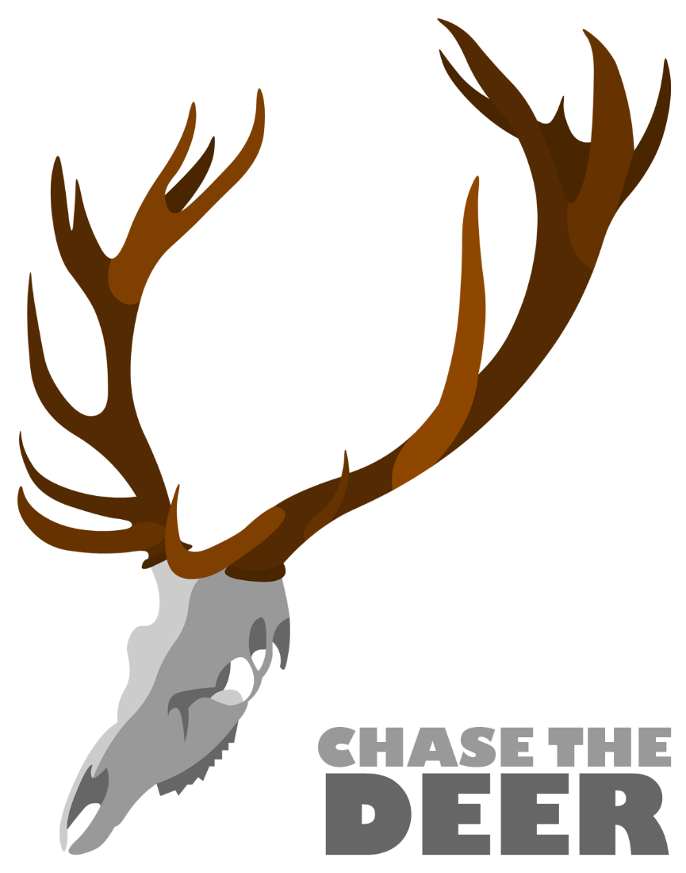
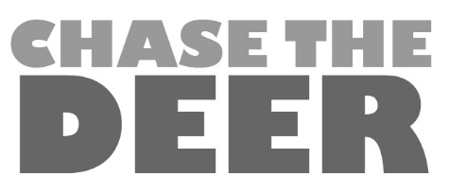
©

Chase the Deer is an unsigned, five piece, Midlands based, Indie Pop/Rock band. The group of close friends from Pershore Sixth Form College formed the band in May 2014. Having started playing covers of their favourite bands including: Bombay Bicycle Club, Young the Giant and Two Door Cinema Club, they have quickly moved on to writing and performing their own songs.
Right from the start they have set out to be an open band, sharing rehearsals and performances online. Anyone who dreams of being part of a band can be part of Chase the Deer by following them on facebook, twitter or youtube.
Chase the Deer have just been accepted onto the M.A.S RECORDS music development programme. M.A.S Records, who were founded in 2001 by Kevyn Gammond (ex-Band of Joy), with Robert Plant (ex-Led Zeppelin) and Karl Hyde (Underworld) as its patrons, will provide the band with rehearsal and recording time as well as giving support and management advice.
Chase the Deer have recorded their first single, “Think” with Recording Engineer Dave Draper at Tower Studios, Pershore. Reviews of the new single have been very positive, “Heavy guitars and powerful drumming combine with appealing vocals and a strong melody to create this impressive debut single by Chase the Deer, a five piece band from Worcestershire” FreshontheNet Blogger Jim (http://freshonthenet.co.uk/2014/10/jims-pick-n-mix-5/)
In the summer the band performed at local music festival Snodfest. Also on 8th November the band to play at the O2 academy 3 in Birmingham supporting the Antarctic Monkeys and Casual Agenda. They also played a live streamed session for Feutral Records in Birmingham. The band will continue to work closely with this exciting new indie start up in the New Year.
December has been an extremely exciting month for the band starting with a couple of private gigs and charity events. They also won a competition to open Worcester Kidz Live at the Worcester Arena. The band have now recorded their single “Bad Date” which will be released in the March.
The band’s shared dream is to play to a crowd and hear them singing along to their songs.

The band comprises of:
Briony Watkins Lead vocals
Owen Taylor Guitar
George Frangoudes Guitar
Angus Evans Bass Guitar
Michael Evans Drums
Further details of the band, videos and pictures are available at:
https://www.facebook.com/ChaseTheDeer
https://twitter.com/ChaseTheDeer
https://www.youtube.com/ChaseTheDeer
https://soundcloud.com/chasethedeer
To contact the band please email us at chasethedeer@outlook.com or call 07790488651, 07896597280 or 01905767876
