Tech Rider, Ida Wenøe
Duo set up:
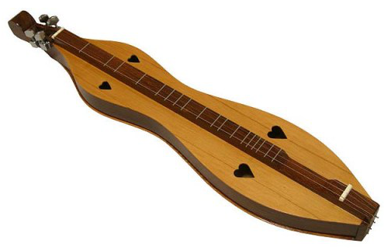
2x vox (lead & choir)
2x DI (2 acoustic guitars)
Mic for guitar amp
Mic for dulcimer (see picture)
Acoustic piano if possible
2 chairs

