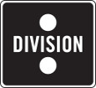
“Brilliant stuff… [Muscle & Bone has] had such a strong reaction” – BBC Introducing

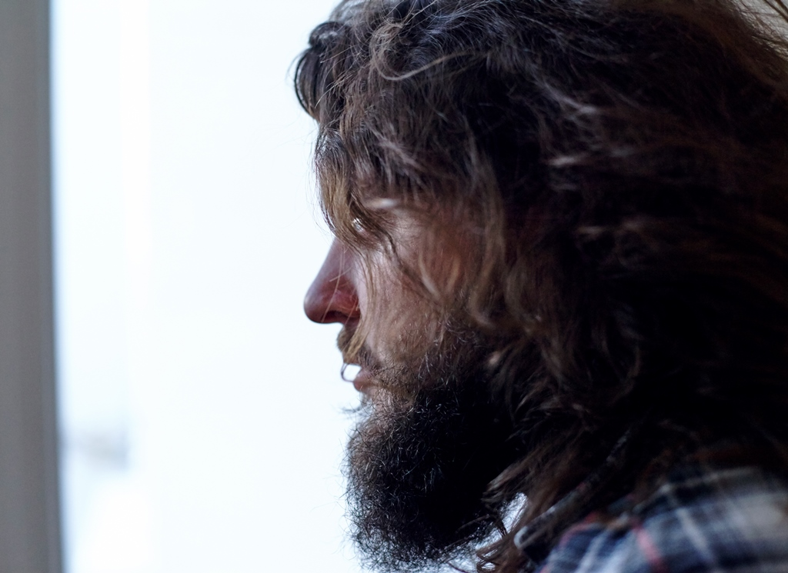
JOHN JOSEPH BRILL
Announces debut EP Pieces due February 23rd via Killing Moon Records
March tour dates announced w/ BC Camplight
Watch music video ‘Muscle & Bone’
http://youtu.be/usGK6oZ2-T0

facebook.com/JohnJosephBrill | twitter.com/johnjosephbrill | soundcloud.com/johnjosephbrill

February 23rd will see Merseyside songwriter John Joseph Brill release his stunning debut EP, Pieces via Killing Moon Records.
Following 2014’s ‘Muscle & Bone’, a brutal study of the agony of making oneself presentable to the world-at-large, whilst simultaneously dealing with life-changing personal issues, John Joseph Brill emerges with a debut EP of beautifully crafted songs that are equally affecting as they are anthemic.
“The Pieces EP was the catalyst for creative awakening,” John Joseph Brill reveals. “With ‘Pieces’ I found myself empowered with a new-found ability to articulate things never previously said aloud.”
Son of a music producer/A&R and a pop singer, you could say John Joseph Brill’s very existence was forged in the music business, but it wasn’t until his teenage years that he took his own first steps into music. “I concentrated on lyrics more or less exclusively. It wasn’t until the age of 16 that I picked up a guitar and actually put music to my sophomoric sixth-form poetry”. While the majority of his peers were into passing fads, Brill would find himself in isolation listening to Neil Young records.
After dropping out of university John Joseph Brill was invited to front London doom-folk outfit Burning Beard, and soon found himself part of the West London musical hub populated by the likes of The Staves, Laura Marling and Bear’s Den. It was around then he penned the EP’s title track, Pieces, which he describes as being “about an individual who starts off with such staunch principles – politically, morally, whatever, in a very idealistic sense – only to later betray those essentially for the sake of making money”.
Recorded with rising producer Kristofer Harris (Annie Eve, Smoke Fairies, Jay Brown, Bear’s Den, Story Books), the Pieces EP also features live favourite ‘Golden Kids’ and ghostly closer ‘Sleeping Beast’, as well as title track and 2014’s powerful ‘Muscle & Bone’.
The Pieces EP will be released digitally worldwide on 23rd February 2015 via Killing Moon Records. Pre-order here and catch John Joseph Brill live in February and in March supporting BC Camplight at the dates below.
EP Track listing
1. Pieces
2. Muscle & Bone
3. Golden Kids
4. Sleeping Beast

UK Tour dates

February
25th London, The Islington (EP launch)
27th Bath, The Boater

March tour (supporting BC Camplight)
8th Bristol, Louisiana
9th Birmingham, Hare & Hounds
10th London, The Lexington
11th Liverpool, Leaf

- - -
For further information please contact Dave Palmer at Division Promotions.
dave@divisionpromotions.com / 0208 962 8282

