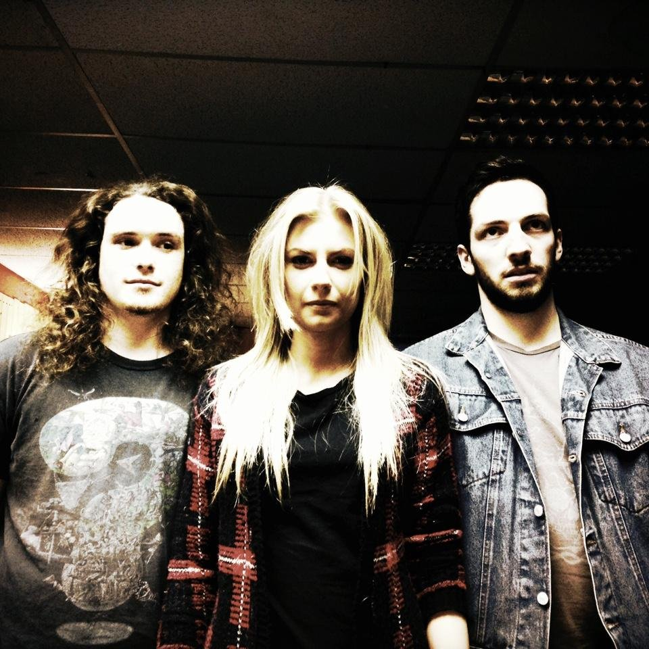
A brooding alternative rock outfit based in Newcastle upon- tyne.
ilser formed in late 2013 and although they have been gigging for little over a year they have been a constant presence in the NORTH EAST music scene.
drawing as much from the blues as they do from rollicking riff-driven heavy metal, their tracks are firm fan favourites.
rounding off the bands first year, they released a two track single that bookmarked the end of a formative period, which has seen the trio receive airplay from nick Roberts on bbc introducing, back a range of coveted international & domestic touring artists, and most importantly of all – continue to hone their unique and already recognisable sound.
Since they began gigging in February 2014 ilser have backed the likes of australia’s the red paintings and grammy-award winning bluesman amund maraud. ilsers set showcases perfectly chief songwriter rachael whittle’s ability to juxtapose ethereal melody with raw aggression and power.
Ilser are set to have a busy 2015 with gigs already lined up around the North East as well as an appearance at Stockton calling in April.
the band would like to invite you to take a listen to their music. you may do so via soundcloud by clicking here. if you would prefer an alternative format or downloads, please don’t hesitate to request.
find ilser online: Facebook | twitter | soundcloud

for more information contact:
ilserband@gmail.com

