
THE ZANGWILLS -TECHNICAL RIDER

IF ANY OF THE SPECIFIC REQUIREMENTS IN THIS DOCUMENT CANNOT BE MET, PLEASE CONTACT US ASAP AND WE WILL TRY TO ACCOMMODATE.

MEMBERS
JAKE VICKERS - LEAD VOX, GUITAR, SYNTH AND KEYBOARD
SAM DAVIES - GUITAR AND BACKING VOX
ED DOWLING - BASS AND BACKING VOX
ADAM SPENCE - DRUMS

JESS LEES – BACKING VOX

CONTACT
thezangwills@hotmail.com or jelmusic@outlook.com
07835 429914 - JACKIE LEES (ARTIST MANAGER)
07460 177017 - ED DOWLING
07791 476971 – SAM DAVIES

REQUIREMENTS
- 5 FOLDBACK MONITOR (3 as back-up/support)
- 3 STEREO IN EAR MIXES (DEPENDING ON VENUE)
- Mics Per Spec or close match
- 5 ACTIVE DI BOXES FOR SYNTH, BASS AND TRACK (L+R+CLICK)
- ALL NECESSARY STANDS AND XLR LEADS

INPUT CHANNEL LIST
CHL | INST | MIC | 48v | STAND
1 | KICK IN | 91A / 901 | X
2 | KICK OUT | Audix D6/902 |  | SHORT
3 | SNARE Top | SM57/E904 |  | SHORT
4 | SNARE Bottom | E904/SM57 |  | SHORT
5 | HATS | KM184 | X | SHORT
6 | RACK | E904
7 | FLOOR | E904
8 | OH L | KM184 | X | TALL BOOM
9 | OH R | KM184 | X | TALL BOOM
10 | BASS DI | ACTIVE DI | X
11 | FENDER HOT ROD | Senn 906 |  | SHORT
12 | VOX AC30 | Senn 906 |  | SHORT
13 | SYNTH (MONO) | ACTIVE DI | X
14 | KEYS L | XLR OUT
15 | KEYS R | XLR OUT
16 | GUITAR VOX | E935/SM58 |  | TALL BOOM
17 | JESS VOX | E935/SM58 |  | TALL BOOM
18 | LEAD VOX | E945* |  | TALL BOOM
19 | BASS VOX | E935/SM58 |  | TALL BOOM
20 | TRACK L | E935/SM58 |  | TALL BOOM
21 | TRACK R | ACTIVE DI | X
22 | CLICK TRACK | ACTIVE DI | X

*PROVIDED BY BAND

PLEASE NOTE
Stage plot diagram includes Jess behind Sam however, this position is flexible due to stage size and dimensions.
We also have a Behringer 8 channel DI Rack as back up incase the venue does not have enough DI boxes.

Adam (drums) is using a wired stereo in ear monitor system. Foldback monitor as back-up.
Ed (bass) and Jess (backing vocals) are using a stereo Sennheiser wireless iem system. Foldback monitors as back-up.
Jake (vox, synth, guitar and keys) and Sam, stage right both require a foldback monitor.

Our backing track system consists of a MacBook running logic pro x into a focusrite 18i20, with 3 outputs (L&R and click) – this is used in 5 songs throughout the set.

Both Sam and Jake switch lead guitar in songs, we will provide a setlist with details regarding this before soundcheck.
Synth is a Korg Minilogue which is mono – requires reverb (Jake).
Keys is a Vox continental which is stereo – requires reverb (Jake).
Bass amp is a TC electronic rh450 head into an Ashdown 4x10 cab
Drum kit is a Mapex m birch with a 22” kick (with mic port) and a Tama Starclassic aluminium snare.

STAGE PLAN

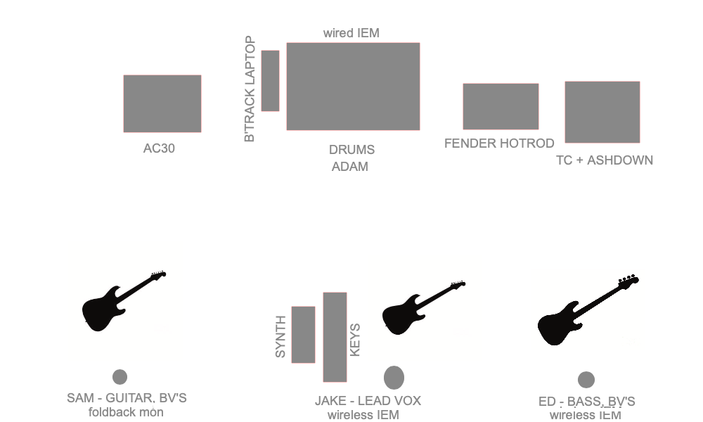
Backing track laptop
Foldback mon
Wireless IEM
JESS – BV’S

