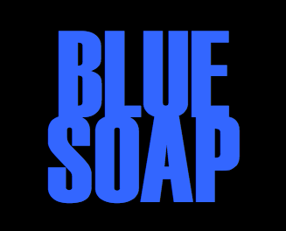
The Watchmakers

Their new single on Loaded Soul Records
Illumination

Release Date: Thursday 12th June 2014
Format: Limited Edition Vinyl & Digital Download

“The band’s vintage psych sound – all driving guitars, pounding bass and crashing drums – is like a battering ram to the senses, a perfect cocktail of Brian Jonestown Massacre menace and Spacemen 3-esque trippyness.”
David Sue - Manchester Evening News, May 2014
Combining the sounds of classic 60s psychedelia with The Verve, The Brian Jonestown Massacre and Primal Scream, Manchester based four piece The Watchmakers have created a unique blend of psychedelic rock n roll. Their self-produced demos Before Questions Became and Waves earned the band high praise and airplay from the likes of John Kennedy at XFM and BBC Manchester Introducing, leading to seasoned music lovers and music industry insiders clamouring for more material.

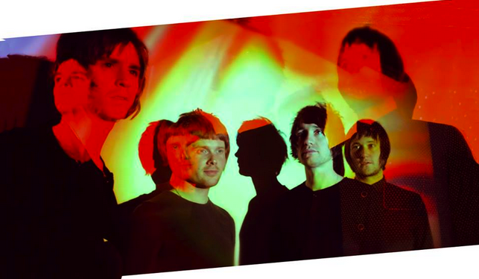
L-R:

Following headline appearances at two sold out Psychedelic Happenings in Manchester as well as playing with the likes of The Pretty Things, Jacco Gardner, Dark Bells and Exit Calm, The Watchmakers were invited to play a BBC Showcase in February 2014 where BBC 6 Music recommended them as ‘ones to watch’. June 2014 see the release of two new tracks – Illumination and Carpe Diem. The songs, the first release from the Manchester based label Loaded Soul Records, will be available on limited edition vinyl and digital download.

“Imagine if Noel Gallagher’s solo record had actually been willing to cut loose and explore its boundaries, and you might be arriving somewhere near to their sound”
Drowned In Sound

“One of the juiciest psych-rock delights you could pluck from the music playing fields of the UK now” Louder Than War review of Before Questions Became

“The visceral charge of Black Rebel Motorcycle Club and the psychedelic adventure of Primal Scream” Manchester Evening News

For Interviews, live sessions and photographs please contact:
Andrea Lynch - andrea@bluesoapmusic.com 0161 947 0012 or 07851 064 020

