

First of all, thank you for your interest in booking a show for Grace de Gier. Below is a list of our technical requirements. It might sound a bit formal to you, this is not meant to cause any inconveniences on your behalf. We designed this rider for optimum effectiveness at the day of the show. If there are any questions or if you have trouble providing any of the below mentioned please get in touch with us before the day of the show and we will work out a solution.

Our stage setup is:
1 Drumset
1 Bass Guitar
2 Electric Guitars
2 vocals ( lead singer) (backing vocalist)

We assume that there is a well sized PA system provided for the concert room with sufficient power to supply a clean and undistorted 110dB SPL RMS to the mixing desk and a powerful and feedback-proof monitor system. It is very important that the singers and the drummer each have their own monitor speakers with separate mixes. For venues over 300 people we will need two extra monitors for the guitar players and two side fills for really large venues

The minimal set up
for small venues
up to 150 people (microphones are listed in order of preference)

DRUMS KICK AKG D12E, Sennheiser MD421, Electro Voice PL20 / RE20, Beyer M88, AKG D112
SNARE TOP Shure SM57
SNARE BOTTOM Shure SM57
HIHAT Neumann or Gefell small diaphragm condenser, AKG C451, any small diaphragm condenser
RACK TOM Sennheiser MD421, Beyer M88, any suitable dynamic mic
FLOOR TOM Sennheiser MD421, Beyer M88, any suitable dynamic mic
OVERHEADS Neumann or Gefell small diaphragm condenser, AKG C451, any small diaphragm condenser (left & right)
BASS amplifier has DI output or choose external DI interface
GUITAR 1
- 1 Monitor (as stated in the stage plan)
- Microphone with microphone stand
- Guitar amp (Minimum 30 watt Tube Amplifier for small stages. Minimum 50 watt Tube Amplifier for bigger stages). Amplifier has DI output or amplified by a Shure M57 or comparible microphone
- Guitar stand for electric guitar
- Guitar stand for acoustic guitar
- Active DI for acoustic guitar

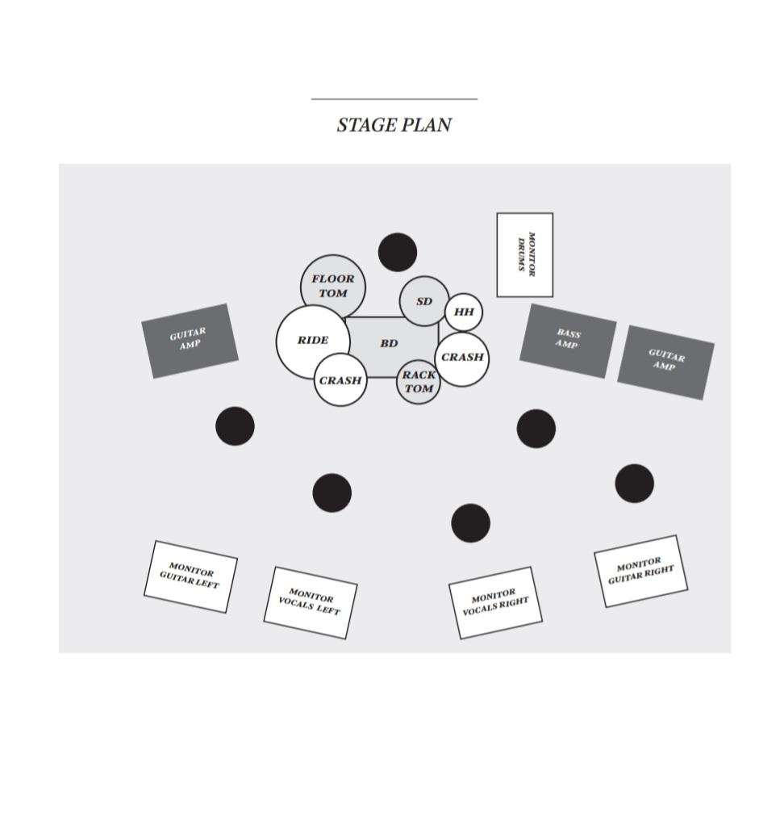
Round base mic stand for male vocalist (if available) Floor carpet (approx. 160cm x 200cm)

for drums on the stage STAFF We will need a qualified sound engineer,
stage technician and lights technician. At the moment we do not have a regular engineer, so we depend heavily on the staff on-site. SOUND & LIGHTING We prefer an overall natural sound with minimal processing and effects.
please use compression. Lighting can be discussed during soundcheck, it is important though that during the show there is always sufficient light for the bass and guitar players to see the fretboard of their instruments with the other bands.
We will need an absolute minimum of 45 minutes soundcheck, 60 to 90 minutes including setup would be perfect. ARRIVAL Please provide detailed directions in English, Dutch or Spanish language two weeks before the date of the show with the complete address of the venue and a telephone contact. We need a safe parking space available for the van close to the venue. Please provide arrival, soundcheck and doors-open and on-stage times. The promoter or another person should be at the venue at arrival time.

Instruments such as:
Saxophone,
Violin,
Accordion, are not included in the standard show. These instruments are required for several songs and increase the price of the concert.

Accommodation and arrangements

1. RIDER - It is agreed and understood that the PROMOTER will provide the following rider in full and at no cost to the ARTIST. These additional clauses and rider form an integral part of the agreement. Failure to sign and return may render this contract null and void. All amendments to this contract must be negotiated with our manager prior to signature.

2. Perfomance – All artwork must be approved by management before going live.

3. DRESSING ROOM - The PROMOTER agrees to provide for the ARTIST's sole use and for the duration of the engagement until curfew, ONE (1) clean, lockable dressing room.

The dressing room should be and have easy access to the musicians preferably without the ARTIST having to walk through the audience.

4. PARKING - The PROMOTER agrees to ensure ample parking space near to venue for ONE (1) vehicle at no cost to the ARTIST and musicians

5. DIRECTIONS - The PROMOTER agrees to provide travel directions to the venue, showing details of parking facilities if requested.

6. TRAVEL EXPENSES - The Promoter agrees to pay all travel expenses on top of fee at all times and hotel accommodation when request-ed for Grace de Gier team.

7. CATERING / DRESSING ROOM REQUIREMENTS - The PROMOTER agrees to provide at its own expense ONE (1) hot meal, and one (1) nutritious cold meal comprised of at least TWO (2) onion-free dishes for Grace de Gier with cold drinks such as water, coke /zero, hot drinks as coffee, tea, etc.

The PROMOTER agrees provide at their own expense, the following refreshments to be placed in the dressing room enough x cans and snacks, fruit, assorted soft drinks or 2L Bottle (Coca-cola zero & coca cola) 16 x clean towels

