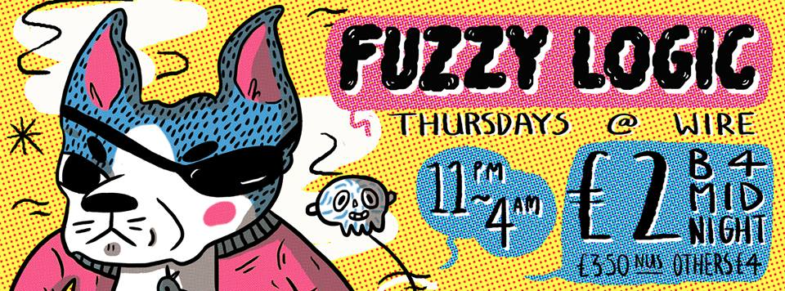

Fuzzy Logic – DJ Tour 2015
PRESS RELEASE

About

2014 saw Leeds’ longest running Indie/Alternative night celebrate it’s 15th birthday; a rare feat in today’s overpopulated clubbing world. Ever since the turn of the century, Fuzzy Logic has had capacity crowds with queues around the corner at it’s home in Wire. Over the years, you could see members of The Cribs, Pulled Apart By Horses, Kaiser Chiefs, Duels, Pigeon Detectives, Black Wire, The Sunshine Underground, The Sugars, Little Boots, Long Blondes and many other local heroes on the dancefloor with the crowds, or taking a turn behind the decks.
So why do we think Fuzzy Logic is still kicking it weekly while other nights have folded? Well, we think it's because we have never been a slave to fashion. We pick the best acts out of each new scene and build them into our already strong and varied playlists. Sure, it's mainly an indie/rock/electro night but if a great song doesn't come under those terms, so what? You want Pop, Northern Soul, Heavy Metal, Ska, Drum & Bass, Motown, Hip Hop, 60's guitar bands? The only question is "can you dance to it?" If the answer is "hell yeah!" then on it goes. You might get Weezer, Maximo Park, ELO, Justin Timberlake, Stevie Wonder, Metronomy, Oasis or Talking Heads. Or all of them. Or none of them! It's a lucky dip approach. We're allowed to like anything, not just what the press tells us to like. No "guilty pleasure"- just pleasure! Always different, always great fun. That's not to say we don't have standards - DJ Debstar's famous sign in the mid 00's stating "No Kooks, No Killers, No Razorlight (No Arguments)" springs to mind.
Fuzzy Logic is constantly changing and evolving and managing to attract new clubbers whilst keeping older ones happy at the same time. It always has one eye on the trends for the future and one foot in the roots of the past. We have the same policy for our guests pleasing the crowds with band DJ sets from the likes of Bombay Bicycle Club, Alt-J, Wild Beasts, Foals, Carl Barat, Peace, The War on Drugs and Carl Barat.
DJ Debstar started the night in 1999 but wasn't always the sole DJ during her time. In 2006 came Pete Fabianski - DJ Fabs. Deb met him when he DJ’ed a private party at Wire and was impressed by his energy, his music collection and his unpretentious sense of fun.

Pete Fabianski has shared the stage with some of Alternative music’s hottest acts as head DJ at the UK’s biggest Indie club night, Propaganda. Fabs has played all over the country at O2 Academies and has previously played at festivals including Bestival, Leeds + Reading, V Festival and Glastonbury. Having two resident DJ's helps keep the night fresh, particularly when their musical tastes are sometimes at odds with each other. Fabs also brought a new style of DJing by putting together loops and mixes on the fly, slick and professional. His sets are eclectic but with a seamless and logical flow, with the odd curveball thrown in to keep it exciting. That is the underlying ethos of Fuzzy Logic.
Through Fabs, Fuzzy has gained its newest curator, Ryan Paul. The pair met whilst at Propaganda. In Ryan’s DJ sets, you can expect a bundle of energy and enthusiasm (he is partial to a crowd surf!), strong mic skills, slick cuts and an eclectic blend of the latest and greatest in all music. Ryan Paul has also played all over the UK and abroad, most notably, playing in Ibiza at Ibiza Rocks as well as playing at UK festivals such as Tramlines, Liverpool Sound City and Beach Break Live. Ryan Paul also has his sights on a career in radio after working up through student radio, he launched the Fuzzy Logic radio show this year and also was chosen from 5000 applicants to make the cut for the BBC Production Talent Pool 2014.

The Tour

Each and every Summer, we take our infamous midweek Indie Disco on the road we’re set for our biggest tour yet in 2015.

Contact

For further interest, please contact:

Ryan Paul, Brand Manager & Resident DJ of Fuzzy Logic
The Faversham, 1-5 Springfield Mount,
Leeds, West Yorkshire,
LS2 9NG
Phone: 07415400997
ryan@wireclub.co.uk

